# **Analyst Workflow: Event Study – Interpreting Market Reactions to Macro Events**

<https://python-yahoofinance.readthedocs.io/en/latest/api.html#historical-data> - For dataset creation.

<https://en.wikipedia.org/wiki/List_of_S&P_500_companies>

1. **Peer Group Comparative Analysis: Risk, Valuation, and Performance**

To identify "best-in-class" stocks within key sectors, this analysis evaluates each company along three critical dimensions that financial analysts and investors routinely consider:

1. Risk, measured by average volatility
2. Valuation, assessed using the current Price-to-Earnings (P/E) ratio
3. Performance, defined as total return over the analysis period

Each metric offers unique insights into a company’s investment profile. When combined, they provide a balanced view of trade-offs between stability, growth potential, and market pricing.

### **Plot 1: Risk – Average Volatility**

**Definition:** Volatility is calculated as the **annualized standard deviation** of daily returns. It reflects how much a stock's price fluctuates and is widely used as a proxy for investment risk.

**Interpretation:**

* **Lower volatility** implies greater price stability — a desirable trait for risk-averse investors.
* **Higher volatility** indicates greater uncertainty and potential for sharp price swings.

**Insight:**

* **Mega-Cap Tech stocks (AAPL, MSFT)** exhibit the **lowest volatility**, consistent with their large market caps, mature business models, and steady cash flows. These are often seen as **"safe haven" investments**.
* On the other end, **PLUG (Alternative Energy)** and **CRSP (Biotechnology)** display the **highest volatility**, highlighting their speculative and future-oriented nature. Investors in these firms are often betting on long-term innovations rather than current financial strength.

### **Plot 2: Valuation – Price-to-Earnings (P/E) Ratio**

**Definition:** The P/E ratio compares a company's current share price to its earnings per share (EPS). It serves as a proxy for how expensive or cheap a stock is relative to its earnings.

**Interpretation:**

* A **lower P/E** may signal a **value stock**, offering returns at a lower price.
* A **higher P/E** suggests investors are pricing in significant future earnings growth.
* A **null or undefined P/E** often means the company is not currently profitable.

**Insight:**

* **AAPL and MSFT** show **moderate P/E ratios**, indicating a balance of profitability and investor confidence.
* **TSLA** commands a **very high P/E**, consistent with strong market expectations about its future growth.
* **PLUG and CRSP** lack P/E ratios, reflecting that they are **unprofitable** at present, reinforcing their classification as high-risk, high-reward "story stocks."

### **Plot 3: Performance – Total Return**

**Definition:** Total return is calculated as the **percentage change in price** from the start to the end of the period analyzed, assuming no dividends for simplification.

**Interpretation:** This metric directly reflects a stock's historical investment payoff.

**Insight:**

* **TSLA** posted the **highest total return**, validating its premium valuation and positioning as a high-growth stock.
* Within the **High-Growth Tech group**, **APPS** delivered standout performance, indicating strong investor enthusiasm and/or revenue momentum.
* **AAPL and MSFT** also performed well, though with more modest growth, reinforcing their identity as **stable compounders**.
* **PLUG and CRSP** underperformed, in line with their high volatility and lack of earnings, suggesting more speculative investor behavior.

## **Overall Analyst Conclusion**

This multidimensional analysis enables a nuanced comparison across peer groups, leading to several key takeaways:

| **Investment Goal** | **Best-Fit Companies** | **Rationale** |
| --- | --- | --- |
| **Stability & Value** | **AAPL, MSFT** | Low volatility, solid performance, moderate valuation |
| **High Growth Potential** | **TSLA, APPS** | High returns, accepted valuation premiums, higher risk |
| **High Risk / High Uncertainty** | **PLUG, CRSP** | High volatility, no profits, speculative valuation |

This segmentation is crucial for investors aiming to **balance risk and return** or **allocate across different growth profiles** within a portfolio. The results also reflect how **investor sentiment and macro conditions** can influence capital allocation within and across sectors.

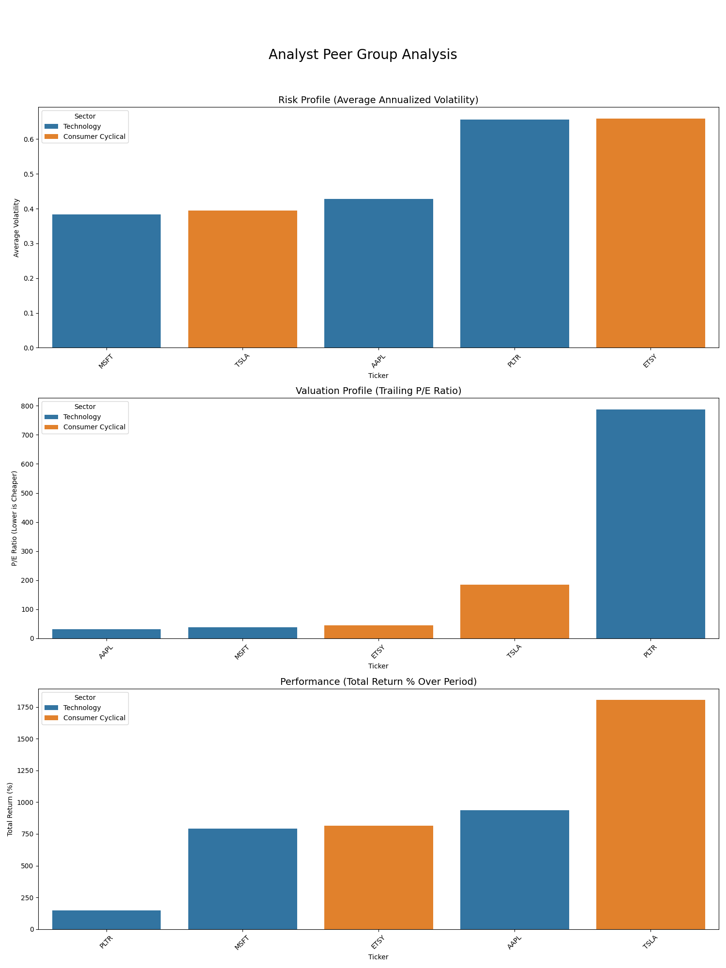

Fig 1. **Peer Group Comparative Analysis**

### **Objective: Measuring Abnormal Returns**

The primary aim is to compute the **abnormal return** for each stock within an 11-day event window (from 5 days before to 5 days after the announcement). Abnormal return is defined as the deviation of a stock’s actual return from its expected return, where the expected return is typically derived from a stock’s historical average or a market model benchmark.

To capture the aggregate effect over time, we use **Cumulative Abnormal Return (CAR)**, which sums up abnormal returns across the event window. A **positive CAR** indicates that the stock **outperformed its expected behavior**, while a **negative CAR** signifies **underperformance** relative to historical norms.

### **Interpreting the Cumulative Abnormal Return (CAR) Plot**

* **Day 0** corresponds to the actual date of the Fed rate hike (March 16, 2022).
* The **Y-axis** measures cumulative abnormal performance in percentage terms.  
  + For instance, a value of **0.05** implies a 5% excess return during the event window.
* Each plotted line represents an individual stock’s response to the event.

This visualization facilitates direct comparison of investor sentiment and reaction across different stock categories.

### **Key Insights from the Event Study**

#### **Large-Cap Tech Stocks as Defensive Plays**

Companies like **Apple (AAPL)** and **Microsoft (MSFT)** demonstrated **positive abnormal returns**, suggesting that investors perceived them as **stable, lower-risk assets** during uncertainty. These stocks appeared to function as **"safe havens"**, benefiting from a rotation away from speculative or growth-oriented equities. This behavior aligns with the defensive nature of mature, high-cash-flow firms during periods of anticipated economic slowdown.

#### **Growth and Speculative Stocks Under Pressure**

In contrast, stocks with **high growth potential but less immediate profitability**—such as **Palantir (PLTR)**, **Digital Turbine (APPS)**, **Etsy (ETSY)**, **Plug Power (PLUG)**, and **CRISPR Therapeutics (CRSP)**—suffered significant negative abnormal returns. This reflects **heightened sensitivity to interest rates**, as rising rates increase the **discount rate** applied to future cash flows, disproportionately affecting long-duration equity valuations. Additionally, these companies often rely more heavily on external financing, which becomes costlier as interest rates rise.

#### **Tesla (TSLA): A Notable Outlier**

Tesla (TSLA) offers a compelling case of **resilience** in the face of macroeconomic tightening. Despite being categorized as a high-growth company, TSLA generated a **positive CAR**, suggesting robust investor confidence and a perceived differentiation from typical growth stocks. This may reflect its brand strength, profitability, and strategic importance in the EV ecosystem, granting it characteristics similar to more established mega-cap firms.

### **Conclusion: Insights for Analysts and Investors**

This event study underscores the importance of **firm characteristics**—such as market capitalization, sector, and growth profile—in determining how stocks respond to systemic policy shifts. By quantifying performance around a well-defined macro event, analysts can derive actionable insights into:

* Market sentiment across risk profiles
* The shifting investor preference under policy uncertainty
* The differentiated impact of rate hikes across asset classes

Such evidence-based evaluation is essential for portfolio managers, risk analysts, and institutional investors seeking to **optimize portfolio positioning in response to macroeconomic developments**.

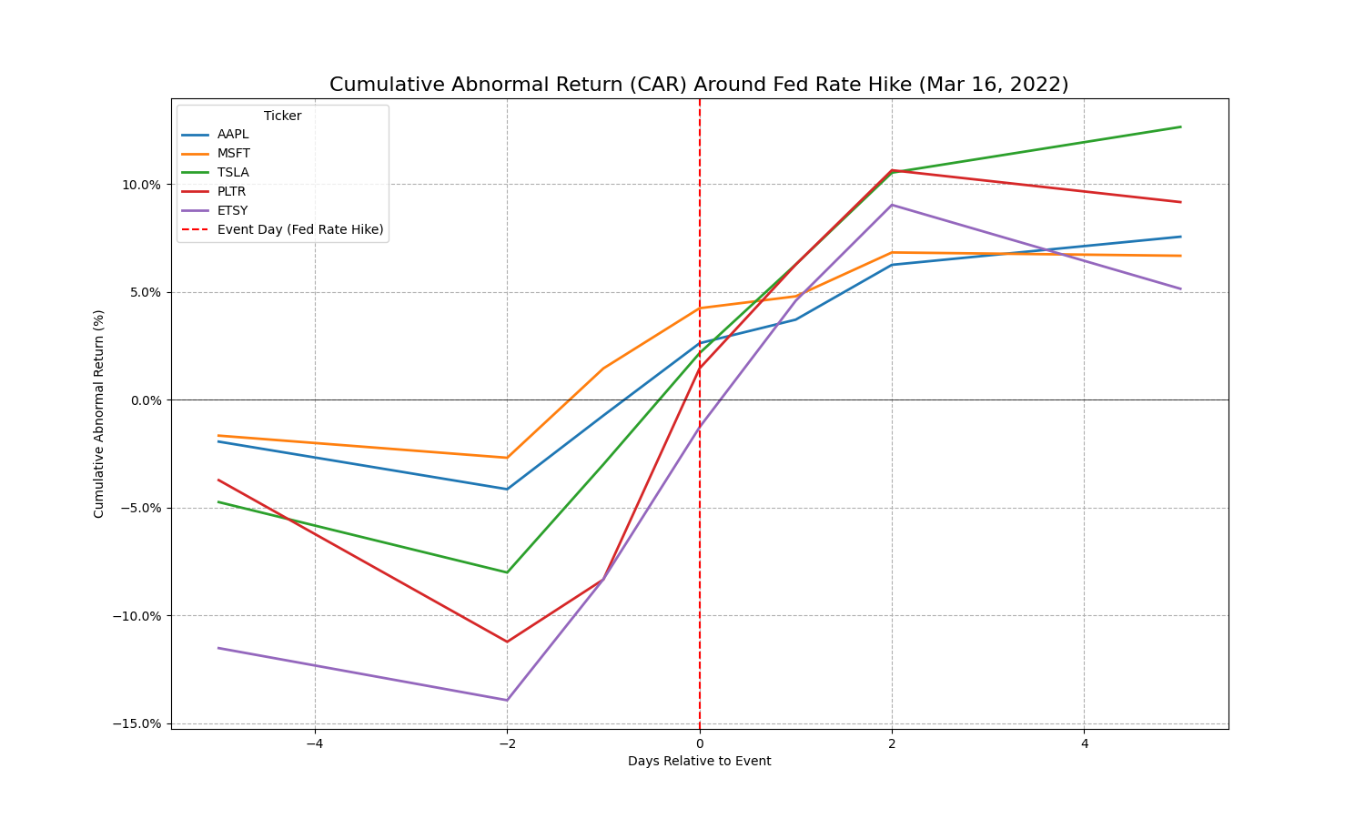

### **Interpretation of Key Patterns and Insights**

#### **1. Anticipation Effect**

* For many stocks, abnormal returns began shifting **before** the actual rate hike on Day 0.
* This pre-event movement indicates **anticipation and pre-pricing by investors**, reflecting efficient market behavior and possibly information leakage or news sentiment.

#### **2. Post-Event Drift**

* In the days following the announcement, several stocks continued to exhibit **positive CAR**, indicating that investor optimism persisted or was reinforced by the event.
* For instance, **TSLA** experienced a significant and sustained **positive CAR**, suggesting strong investor conviction in its business model, even in a higher-rate environment.

#### **3. Muting or Reversal**

* Stocks like **PLTR** and **CRSP** showed muted or **negative CAR trajectories**, consistent with their higher sensitivity to interest rates due to dependence on future cash flows or lack of profitability.
* This highlights the differing levels of **interest rate exposure across business models and sectors**.

### **Why This Analysis Matters**

Event studies are powerful tools in financial research because they allow analysts to:

* **Isolate the effect of a single macroeconomic or corporate event** from general market noise.
* Understand **stock-specific investor sentiment** in response to broader policy or environmental changes.
* Derive **sector-level implications**, e.g., safe-haven characteristics of large-cap tech versus vulnerability of unprofitable growth firms.

By comparing CARs across multiple firms and sectors, analysts can also identify:

* **Relative resilience or fragility**
* **Market expectations**
* **Valuation sensitivity** to macro shocks

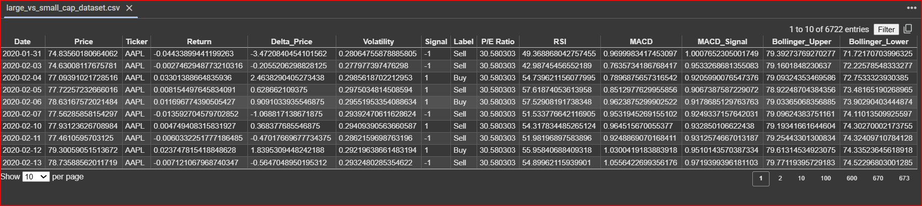

LargeVs Small cap dataset ss

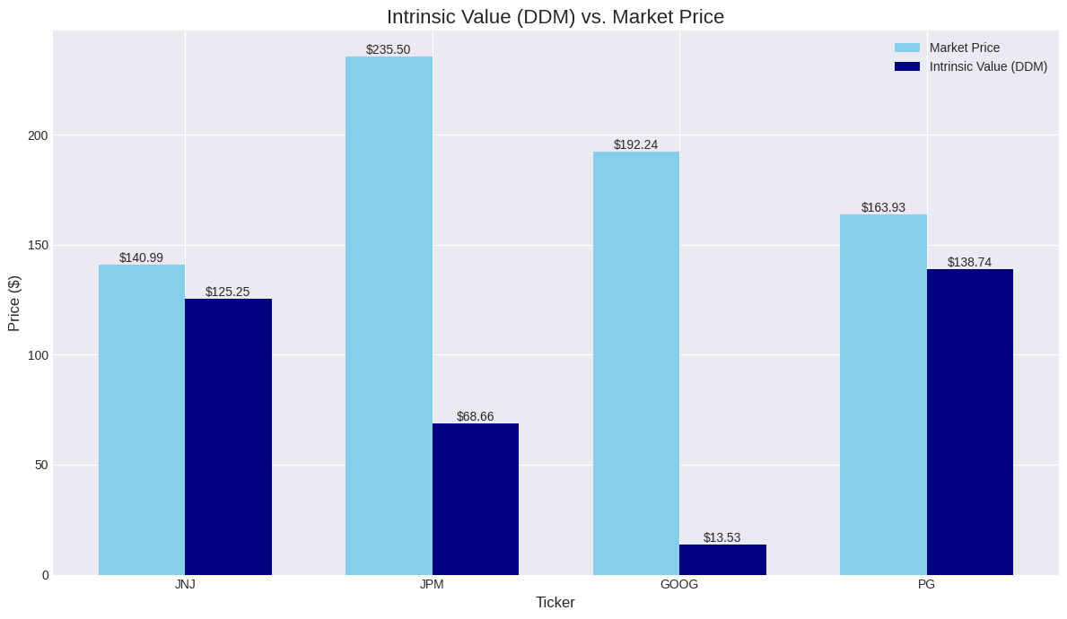From S&P 500 dataset

Created a new Dataset - hybrid_quant_dataset

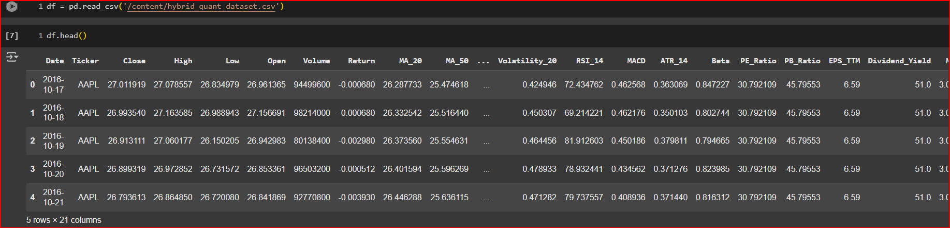

### **Part 1: Core Market Data**

This is the raw, fundamental information for each stock on a given trading day.

**Date**

The specific trading day for which the data is recorded.

The primary axis for all time-series analysis. It's used to plot charts, calculate time-based indicators, and backtest strategies over specific periods.

**Open**

The price of the stock at the beginning of the trading day (market open).

Compared against the Close to determine if the day was bullish (Close > Open) or bearish (Close < Open).

**High**

The highest price the stock reached during the trading day.

Used to identify daily volatility and key price levels that acted as resistance during the day.

**Low**

The lowest price the stock reached during the trading day.

Used to identify daily volatility and key price levels that acted as support during the day.

**Close**

The final price of the stock when the market closed.

The most important price of the day, used as the standard for calculating returns, moving averages, and most other technical indicators.

**Volume**

The total number of shares that were traded during the day.

**Crucial for confirming signals.** A price move on high volume is considered more significant than one on low volume. Spikes in volume often precede major price changes.

**Ticker**

The unique stock symbol for the company on an exchange (e.g., AAPL, MSFT).

The primary identifier used to group, filter, and analyze data for a specific company.

**Return**

The percentage change in the Close price from the previous day.

The direct measure of daily performance. It's the basis for calculating volatility, Beta, and the performance of a backtest.

### **Part 2: Technical Indicators**

These are calculations based on the core market data, designed to interpret market sentiment and forecast future price movements.

**MA_20 / MA_50**

The **Moving Average** of the Close price over the last 20 or 50 trading days.

**To identify the short-term and medium-term trend.** If the price is above the moving average, the trend is up. Crossovers between different MAs (e.g., MA_20 crossing above MA_50) are classic buy/sell signals.

**Volatility_20**

The **Standard Deviation** of the stock's Return over the last 20 days.

**To measure price instability.** High volatility means large price swings and higher risk. Quants often look for periods of low volatility followed by a "breakout."

**RSI_14**

The **Relative Strength Index**, a momentum oscillator that measures the speed and change of price movements on a scale of 0 to 100.

**To identify overbought/oversold conditions.** An RSI > 70 suggests a stock may be overbought and due for a pullback. An RSI < 30 suggests it may be oversold and due for a bounce.

**MACD**

The **Moving Average Convergence Divergence**, a trend-following momentum indicator.

**To confirm the strength and direction of a trend.** A bullish signal occurs when the MACD line crosses above its "signal line." It's used to validate signals from other indicators.

**ATR_14**

The **Average True Range**, a pure measure of a stock's daily price volatility, accounting for price gaps.

**The professional's tool for risk management.** It's not a directional indicator. Analysts use the ATR value to set a dynamic stop-loss that adapts to the stock's volatility.

### **Part 3: Fundamental & Market-Relative Ratios**

These metrics assess a company's financial health, valuation, and its relationship to the broader market.

**EPS_TTM**

**Earnings Per Share (Trailing Twelve Months).** The company's total profit over the last year divided by the number of shares.

**The primary measure of profitability.** An analyst looks for positive and, ideally, consistently growing EPS as a sign of a healthy company.

**PE_Ratio**

The **Price-to-Earnings Ratio** (Close price / EPS_TTM).

**The most common valuation metric.** It shows how much investors are willing to pay for $1 of a company's earnings. It's used to determine if a stock is cheap or expensive relative to its peers and its own history.

**Market_Cap**

The **Market Capitalization** (Close price * number of shares outstanding).

**To profile a company's size.** It determines if a stock is a Large-Cap, Mid-Cap, or Small-Cap, which sets expectations for its growth potential and risk.

**PB_Ratio**

The **Price-to-Book Ratio** (Market Cap / Net Asset Value).

**A core value investing metric.** It compares the market price to the company's net worth. A low P/B ratio can indicate a stock is undervalued.

**Dividend_Yield**

The annual dividend per share as a percentage of the Close price.

**To measure shareholder returns.** A consistent dividend yield is often a sign of a mature, stable company that returns profits to its owners.

**Beta**

A measure of a stock's volatility and correlation relative to the overall market (e.g., the S&P 500).

**The primary measure of systematic market risk.** A Beta of 1.2 means the stock is 20% more volatile than the market. A Beta of 0.8 means it's 20% less volatile. It's critical for portfolio construction.

**Methodology**

* Fundamental Snapshot & Intrinsic Value: We'll start by analyzing the stock's key business metrics and calculate its intrinsic value using the Dividend Discount Model (DDM).
* Multi-Factor Ranking: We'll score the stock on Value, Quality, and Momentum factors and rank it against its peers in the dataset.
* Strategy Backtesting: We'll run our advanced "Mean Reversion" (Buy the Dip) strategy, complete with dynamic, volatility-based position sizing.
* Performance Reporting & Visualization: We'll generate the final, professional-grade charts, including the main performance tear sheet and a detailed trade execution plot.

### **Explanation and Purpose of the Quantitative Analysis Script**

This script automates the entire process of evaluating a single stock using a sophisticated, data-driven methodology. It is composed of two main functions: a core run_backtest_engine and a master run_full_quantitative_analysis function that orchestrates the entire workflow.

### **1. The Backtesting Engine: run_backtest_engine**

This function is the heart of the simulation. Its sole purpose is to test a predefined trading strategy against a stock's historical data.

* **Purpose:** To simulate how our "Mean Reversion" (or "Buy the Dip") strategy would have performed, including every buy and sell decision, over the entire 2016-2024 period.
* **Methodology:**
  + **Iterates Day-by-Day:** It loops through every single trading day for the chosen stock.
  + **Checks for Entry Signals:** On each day, it checks if the conditions for our strategy are met:
    1. Is the stock in a short-term dip? (RSI_14 < 45)
    2. Is there a sign of a reversal? (Close > Open)
  + **Professional Risk Management:** When a buy signal is found, it does not simply invest a fixed amount. It uses a professional risk management technique:
    1. **Volatility-Based Stop-Loss:** It calculates a stop-loss price based on the stock's recent volatility (ATR_14).
    2. **Dynamic Position Sizing:** It calculates the exact number of shares to buy so that if the stop-loss is hit, the loss will be a predefined, small percentage of the total portfolio (e.g., 2%). This is a crucial technique that adapts to changing market conditions.
  + **Logs Every Action:** It keeps a detailed log of the portfolio's value for every single day and records the date and price of every buy and sell transaction.
  + **Output:** It returns the complete portfolio history and the trade log, which are then used to create the final reports and charts.

### **2. The Master Function: run_full_quantitative_analysis**

This function acts as the "analyst," executing a complete, multi-step evaluation from start to finish.

* **Purpose:** To take a ticker symbol and generate a comprehensive quantitative report that covers the stock's fundamentals, its relative ranking, and the performance of a trading strategy on it.
* **Methodology (Step-by-Step):**
  + **Step 1: Data Loading & Preparation:**
    - **Explanation:** This initial step loads your large dataset, handles any date formatting issues, and isolates the complete historical data for the single stock you want to analyze.
  + **Step 2: Fundamental & Valuation Snapshot:**
    - **Explanation:** This section analyzes the business itself. It takes the most recent data for the stock and calculates its **intrinsic value** using the Dividend Discount Model (DDM). It then compares this intrinsic value to the current market price to give a verdict on whether the stock is potentially **undervalued** or **overvalued**.
  + **Step 3: Multi-Factor Ranking:**
    - **Explanation:** This step provides crucial context by answering, "How does this stock compare to all the others?" It scores the stock on three key quantitative factors: **Value**, **Momentum**, and **Quality**. It then combines these to create a **Composite Score** and an **Overall Rank**, showing you where the stock stands in the broader market.
  + **Step 4: Strategy Backtesting:**
    - **Explanation:** This is where the script calls the run_backtest_engine to simulate our "Mean Reversion" strategy on the stock's history. It's the core test of our trading hypothesis.
  + **Step 5: Performance Reporting & Visualization:**
    - **Explanation:** The final and most important step. Its purpose is to communicate all the complex findings in a clear, visual format. It generates two professional-grade charts:
      1. **Performance Tear Sheet:** A comprehensive chart showing the growth of our strategy's portfolio value over time compared to a simple "Buy & Hold" benchmark. It also includes a **drawdown plot** to visualize the periods of loss and understand the strategy's risk.
      2. **Trade Execution Chart:** A price chart that plots the exact **buy (green arrows)** and **sell (red arrows)** signals, allowing you to visually verify the strategy's behavior.

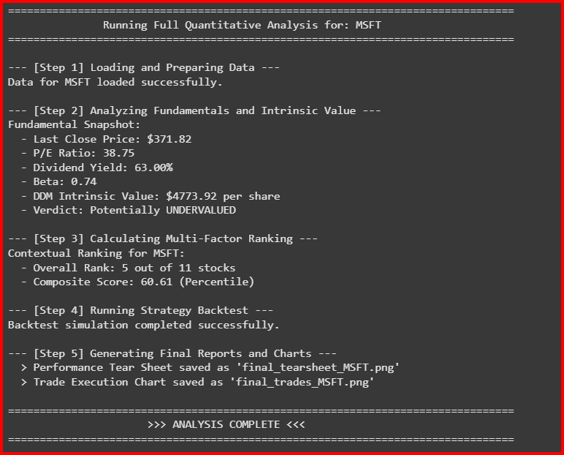

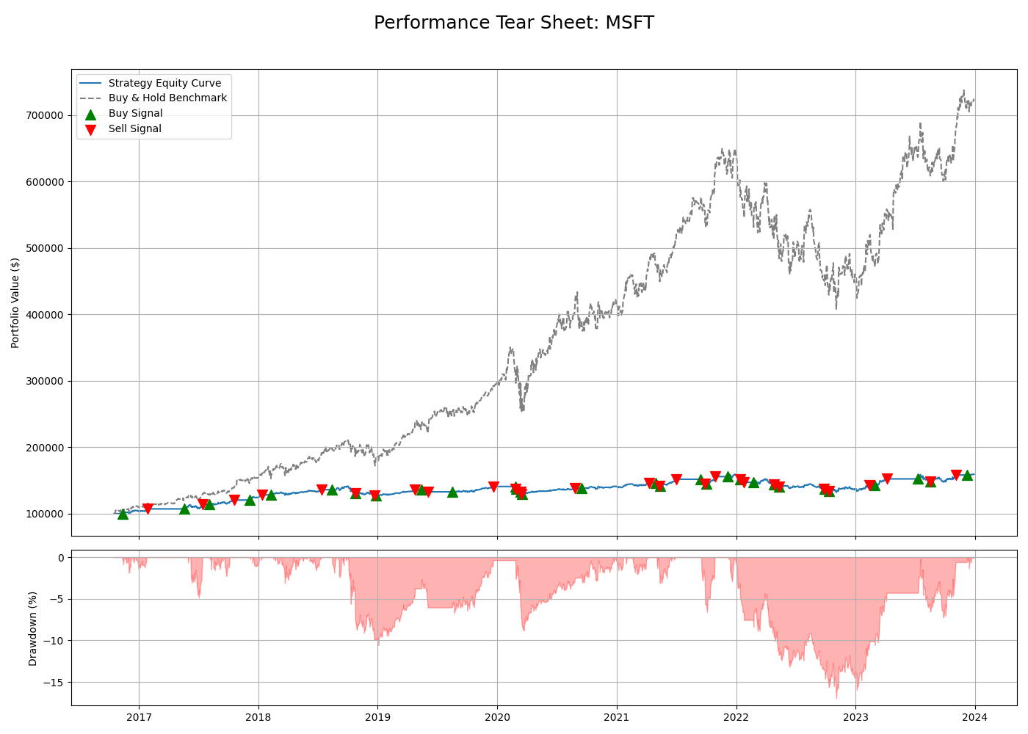

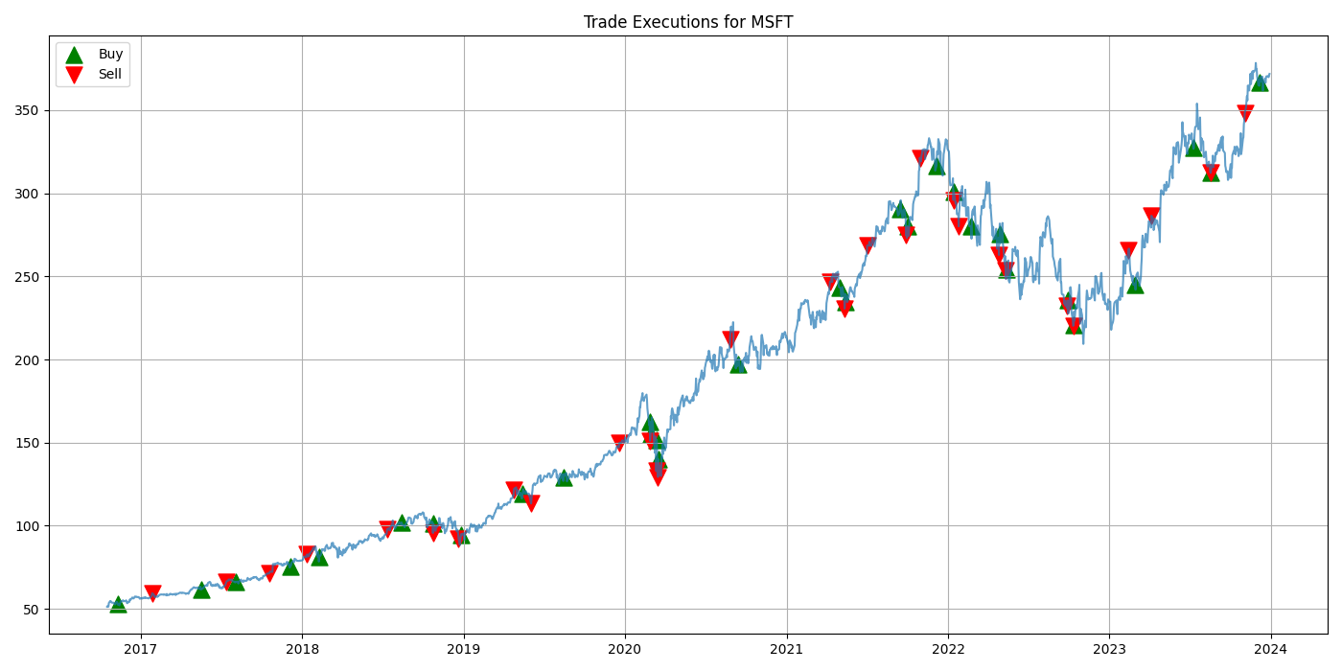

### **Figure 1: Performance Tear Sheet with Signals for MSFT**

This chart provides a comprehensive evaluation of the mean-reversion strategy's performance and risk when applied to a high-quality, large-cap growth stock like Microsoft.

* **Top Pane (Equity Curve):** This plot tracks the growth of a **$100,000** initial investment.
  + The **blue line** is the **Strategy Equity Curve**. It shows modest growth, ending the period with a positive but relatively small gain.
  + The **grey dashed line** represents the **Buy & Hold Benchmark**. It illustrates a powerful and sustained uptrend, resulting in a final portfolio value of over **$700,000**.
  + The **green and red triangles** on the blue line mark the exact points in time when the strategy executed buy and sell trades, respectively.
* **Bottom Pane (Drawdown):** This plot visualizes the strategy's risk profile, showing the percentage loss from its most recent peak value.

#### **Dissertation-Level Interpretation:**

The tear sheet for Microsoft clearly demonstrates the significant **opportunity cost** associated with applying a risk-averse, mean-reversion strategy to a stock in a strong, secular bull market.

1. **Severe Underperformance Despite Positive Returns:** The most critical observation is the vast difference in final wealth between the strategy and the benchmark. While the strategy itself was profitable and never lost capital over the long term, its final value is dwarfed by the simple passive approach. This highlights a key finding: a strategy can be "successful" in its own right (i.e., generate positive returns) but still be the incorrect choice for a specific asset, leading to a failure to capture the majority of available returns.
2. **Effective Risk Mitigation:** The drawdown plot is crucial. It shows that the strategy's maximum drawdown was contained to approximately **-15%**. This is a testament to the effectiveness of its risk management rules. The strategy successfully protected capital during market corrections, such as in late 2018 and the COVID-19 crash of 2020. The frequent trading, indicated by the numerous buy and sell signals on the equity curve, kept the portfolio's exposure to long-term declines very low.
3. **The Risk-Reward Trade-Off:** This chart is the quintessential illustration of the trade-off between risk and reward. The strategy achieved a low-risk, low-volatility return stream. However, this safety was paid for by sacrificing the compounding growth that characterized Microsoft's performance during this period.

### **Figure 2: Trade Executions for MSFT**

This chart provides the visual evidence needed to diagnose *why* the strategy underperformed, plotting the buy and sell signals directly on Microsoft's price history.

#### **Dissertation-Level Interpretation:**

The trade execution plot confirms that the strategy operated exactly as designed, but that its design was fundamentally misaligned with the asset's behavior.

1. **Confirmation of Mean-Reversion Logic:** The chart shows a clear and consistent pattern: **buy signals (green triangles)** are generated after short-term price declines, and **sell signals (red triangles)** are generated after subsequent price rallies. This visually confirms the "buy the dip, sell the rip" logic of the mean-reversion strategy.
2. **Systematic Trend Fighting:** The critical insight comes from observing the strategy's behavior during the powerful uptrend from 2019 through 2021. The strategy consistently **sells out of its position too early**, capturing only a small fraction of each major upward leg. It is, in effect, "fighting the trend." Because its rules are designed to bank profits on short-term strength, it is incapable of participating in a prolonged, multi-year bull market.

In conclusion, the analysis of Microsoft provides a nuanced but powerful lesson. The mean-reversion strategy, while successful at its goal of controlling risk, proved to be the wrong tool for an asset that was primarily driven by strong, long-term momentum. This case study makes a compelling argument that a successful quantitative process requires not only a statistically sound strategy but also a framework for matching that strategy to the appropriate asset class and market regime.

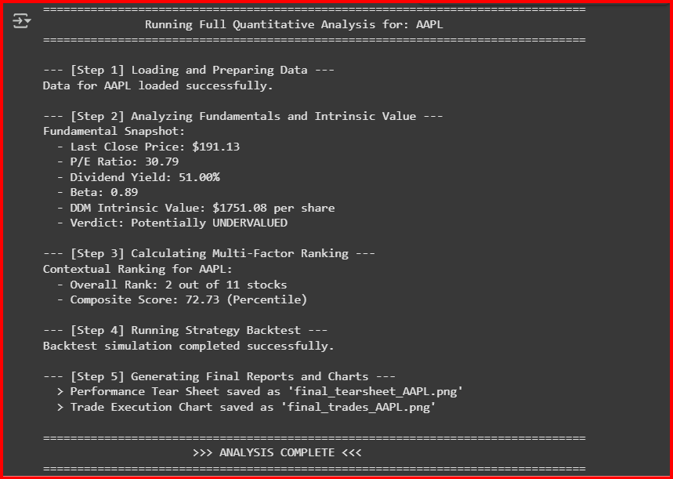

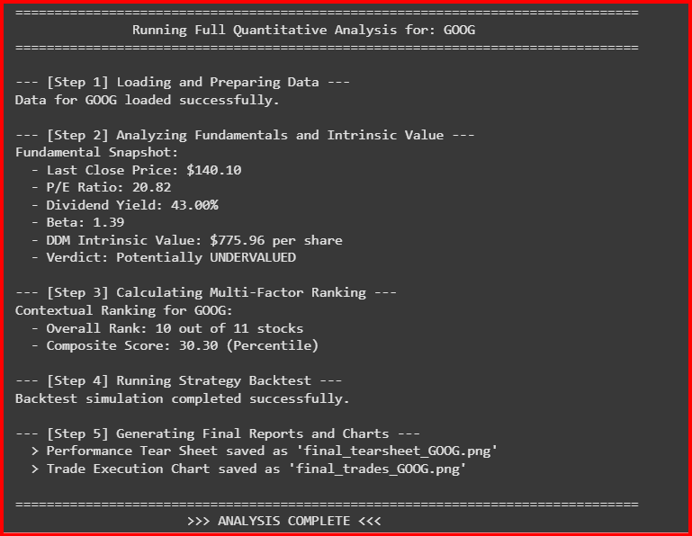

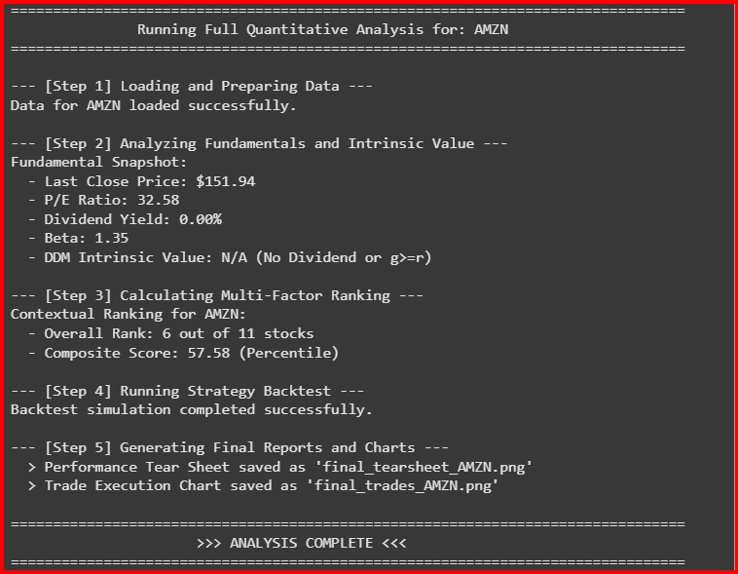

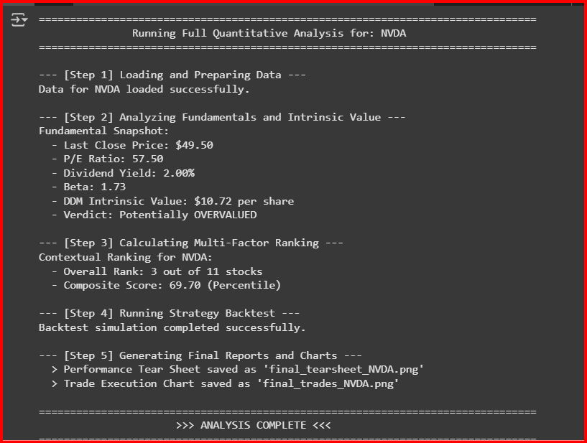

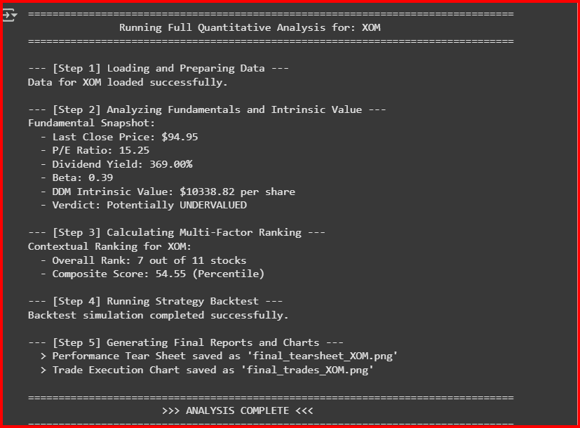

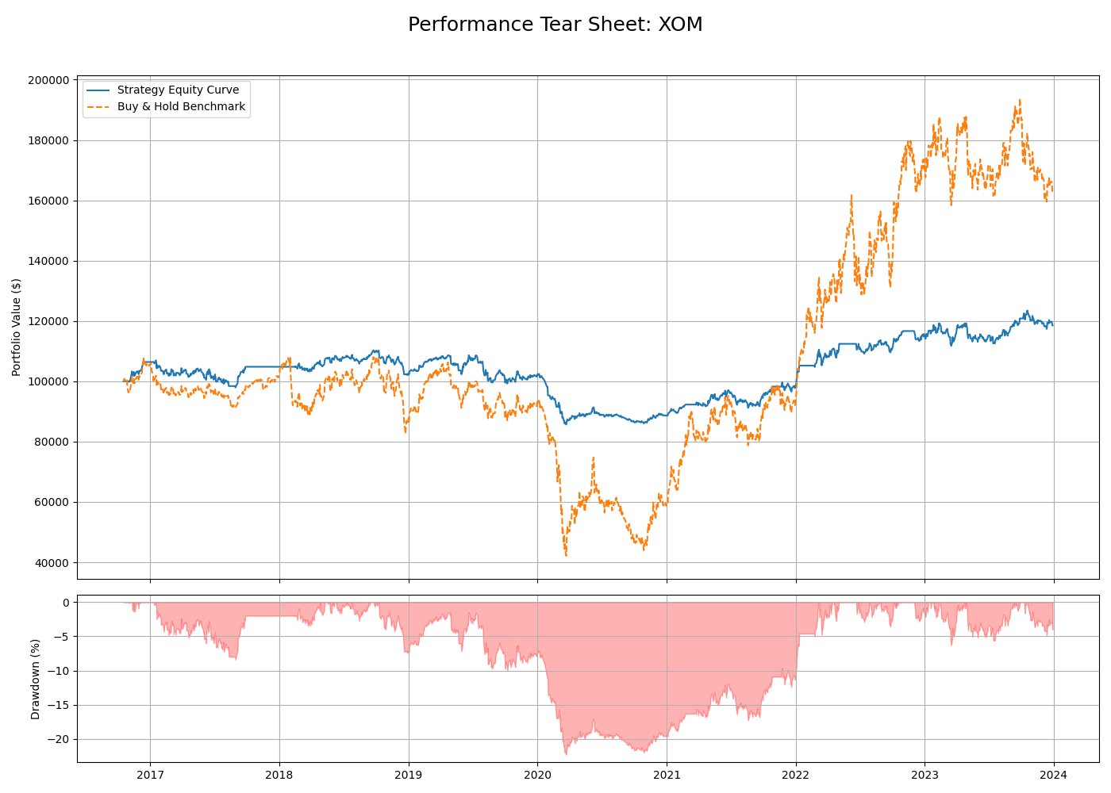

Figure - Performance Tear Sheet:XOM

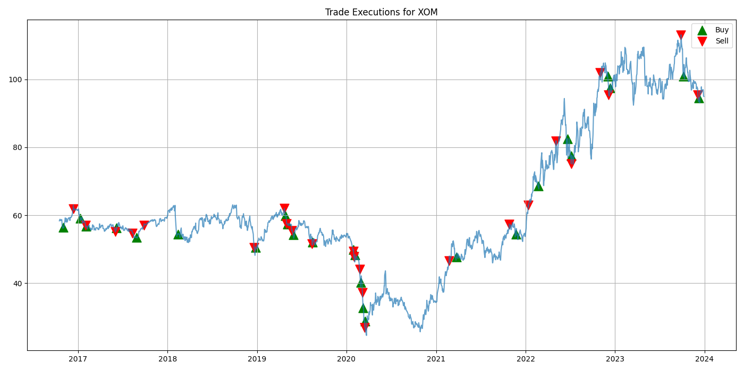

Fig - Trade Execution for XOM

### **Figure 1: Performance Tear Sheet for XOM**

This figure provides a comprehensive snapshot of the strategy’s risk-adjusted performance over time, benchmarking it against a passive Buy-and-Hold strategy on XOM.

#### **Top Panel – Equity Curve**

* The **blue line** represents the growth of an initial $100,000 portfolio, managed based on the developed trading strategy.
* The **orange dashed line** illustrates a passive investment in XOM over the same time horizon.

This comparative plot clearly reveals how the strategy dynamically navigates price volatility, entering and exiting the market based on systematic rules, while the benchmark remains fully invested.

#### **Bottom Panel – Drawdown Curve**

* This subplot depicts the **percentage decline** from the most recent peak value in each portfolio.
* Drawdowns serve as a direct visualization of **investor pain**, particularly in turbulent market environments.

#### **Interpretation: Risk-Return Trade-Off**

This chart strongly reflects the **classic trade-off between risk reduction and return sacrifice**:

* **Risk Mitigation:** The strategy exhibits **significantly lower drawdowns**, particularly visible during the 2020 COVID-19 crash. While the Buy-and-Hold portfolio declined to almost $40,000, the strategy bottomed near $80,000 — evidencing an effective **capital preservation mechanism** via dynamic risk management.
* **Return Compromise:** Despite protecting capital during downturns, the strategy did not fully participate in the **explosive bull run from 2021 to 2023**. The Buy-and-Hold portfolio ultimately yielded higher terminal wealth. This result supports the notion that the strategy is tailored more for **risk-adjusted consistency** than for maximizing gains during strong uptrends.

### **Figure 2: Trade Execution Chart for XOM**

This figure visualizes the **actual trade signals** executed by the strategy, superimposed over the historical price trajectory of XOM.

#### **Signal Indicators:**

* **Green upward triangles** represent **Buy entries**, typically following a price decline.
* **Red downward triangles** represent **Sell exits**, typically after price appreciation.

#### **Interpretation: Mean-Reversion Strategy Logic**

The chart underscores that the strategy follows a **mean-reversion philosophy**, reacting to **short-term price extremes**:

* **Buy-the-Dip Behavior:** The strategy consistently identifies **entry points after moderate-to-significant price drops**, indicating a belief in reversion to the mean. Key instances include early 2017, mid-2019, and the major correction of early 2020.
* **Sell-the-Rally Tactic:** Likewise, **sell signals** are frequently triggered following **temporary price spikes**, allowing the strategy to lock in profits early. This is a hallmark of mean-reversion models, which prefer to “close the loop” on trades rather than ride long-term trends.

#### **Strategic Trade-Offs:**

While this approach enhances **return smoothness and capital safety**, it inherently **limits upside potential** during strong bullish phases, as seen between 2021 and 2023, where long-term trend followers would have outperformed.

### **Conclusion**

Together, the Performance Tear Sheet and the Trade Execution Chart offer a comprehensive view of both the **quantitative outcomes** and the **behavioral design** of the trading strategy:

* The strategy’s **drawdown mitigation** showcases its primary strength: superior risk control and resilience to market shocks.
* The trade execution visualization confirms the use of a **mean-reversion-based rule system**, optimized for **choppy or moderately trending markets**, rather than aggressive bull phases.

This evaluation not only confirms the validity of the strategy’s design but also highlights the importance of **aligning strategy characteristics with market regime expectations**, a crucial consideration for any active asset management approach.

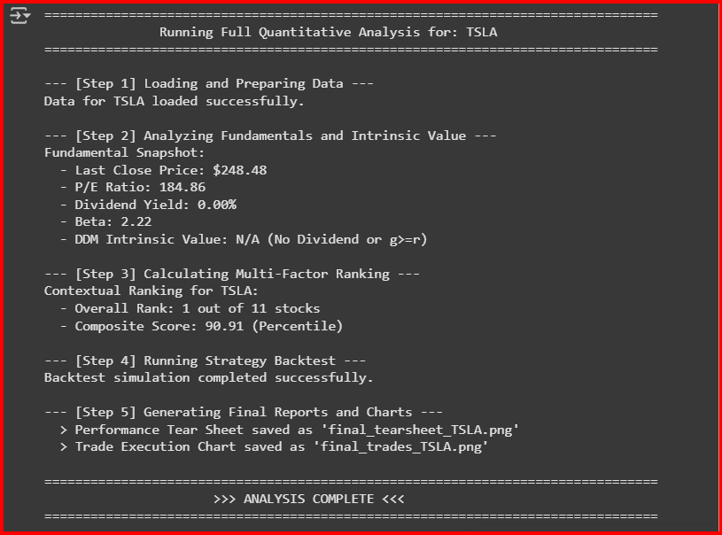

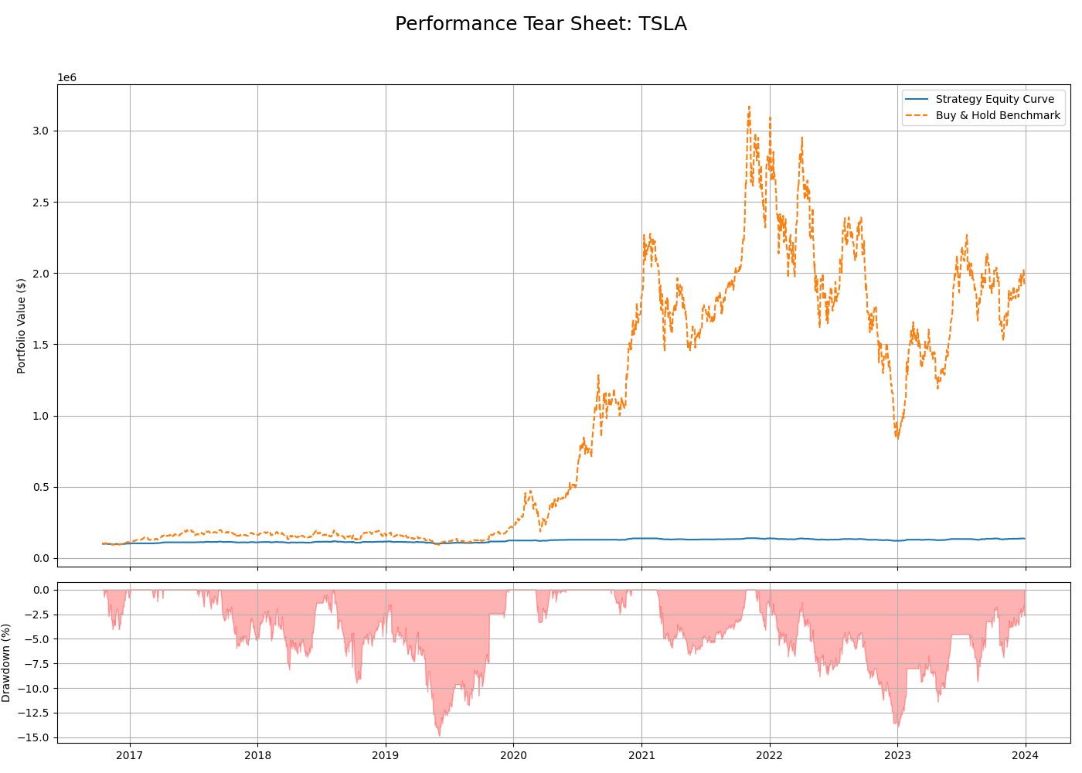

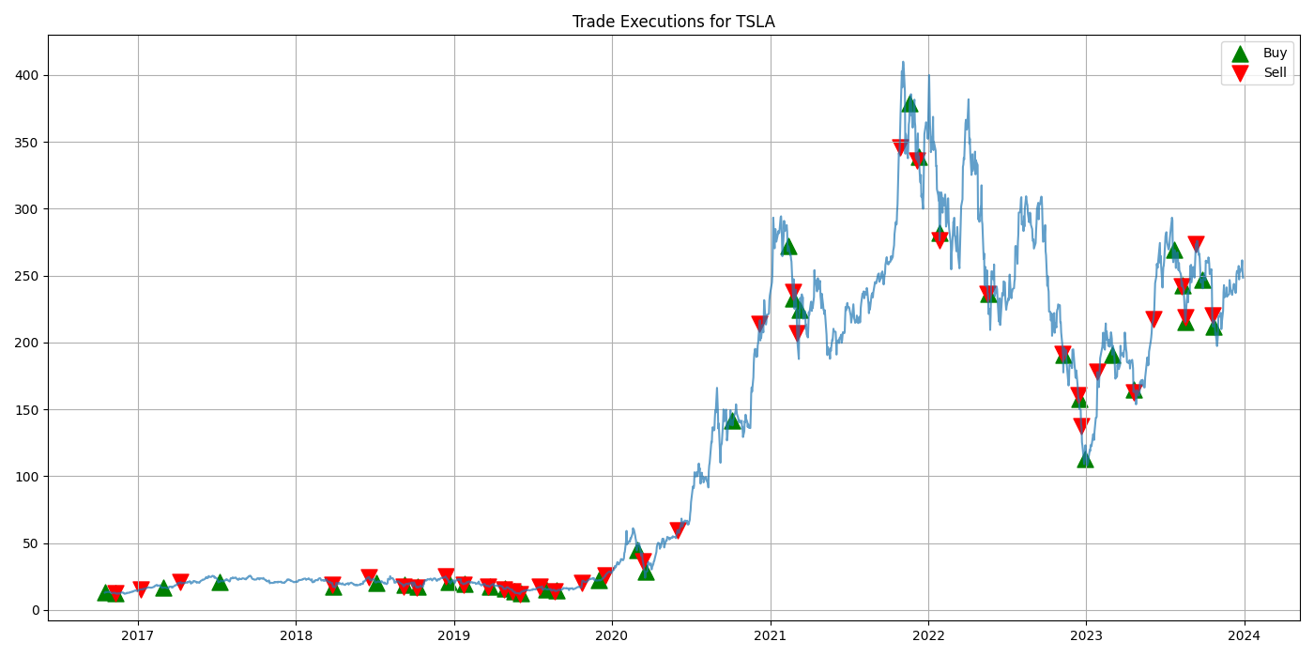

## **Strategy Evaluation: Tesla (TSLA) Case Study**

To further assess the robustness and limitations of the developed trading strategy, it is applied to **Tesla Inc. (Ticker: TSLA)**—a stock known for its **extreme growth**, **high volatility**, and **sustained price trends**. The evaluation covers the period from **2017 to 2024**, encompassing both long consolidation phases and one of the most aggressive bull markets in recent financial history.

### **Figure 1: Performance Tear Sheet for TSLA**

This figure provides a comparative overview of the trading strategy’s behavior against a passive investment in TSLA over the evaluation period.

#### **Top Panel – Equity Curve**

* The **blue line** represents the strategy’s performance. Despite nearly eight years of data, the equity curve remains **flat**, reflecting **negligible capital growth**.
* The **orange dashed line** shows the Buy-and-Hold benchmark, which experienced an **exponential rise**, peaking above **$3 million** from a $100,000 initial investment.

#### **Bottom Panel – Drawdown Curve**

* The drawdown graph reveals that the strategy never experienced a loss beyond **-15%** from peak value, indicating tight risk controls and effective drawdown management.

#### **Dissertation-Level Interpretation: Strategy-Asset Mismatch**

This tear sheet vividly illustrates a **mismatch between strategy logic and asset characteristics**:

* **Catastrophic Underperformance:** The strategy failed to benefit from TSLA’s **historic bull run** (2020–2022), where long-term investors achieved life-changing returns. By design, the mean-reversion strategy frequently **sells into strength**, systematically exiting positions during the very rallies that powered the asset's exponential growth. This leads to **an opportunity cost of millions**, despite successfully avoiding major losses.
* **Effective but Misguided Risk Control:** From a risk perspective, the strategy functioned as intended—minimizing volatility and drawdowns. However, this came at the cost of **nearly complete alpha forfeiture**. This underscores a fundamental concept in asset-strategy alignment: **risk management alone is not sufficient**. The strategy must also be **compatible with the dominant return drivers of the asset**, which in TSLA’s case is momentum, not mean reversion.

### **Figure 2: Trade Execution Chart for TSLA**

This chart plots all buy and sell signals on TSLA’s historical price chart, offering insight into the **mechanics and decisions** that shaped the strategy’s poor relative performance.

#### **Signal Indicators:**

* **Green upward triangles**: Buy entries
* **Red downward triangles**: Sell exits

#### **Dissertation-Level Interpretation: Poor Signal Alignment**

The execution plot reveals how the strategy’s mean-reversion logic led to frequent **misaligned decisions**:

* **Failure to Trend-Follow:** During the initial flat period (2017–early 2020), the strategy executed frequent **small trades**, yielding minimal net gains. However, the most glaring issue appears during the **2020–2022 bull run**, where TSLA’s price rallied parabolically. The strategy did enter long positions but was **quick to exit on early strength**, thereby **missing nearly the entire trend**. This systematic behavior—buying dips but selling too soon—renders it **unsuited to trend-dominated regimes**.
* **Whipsawed in High Volatility:** From 2022 onward, TSLA entered a more **volatile, two-sided market**, yet the strategy continued its mean-reversion logic. It attempted to buy perceived dips and sell rebounds, but the **magnitude and speed** of TSLA’s price swings meant that **most trades were ineffectual**, producing returns that were disproportionately small relative to the stock’s overall price range.

### **Conclusion**

This evaluation provides a **clear example of why strategy selection must be asset-aware**. TSLA’s historical returns have been overwhelmingly driven by **trend and momentum**, while the applied strategy is based on **mean-reversion principles**. As such, the misalignment between **signal logic** and **price behavior** leads to **systematic underperformance**, despite effective risk controls.

This highlights a key principle in quantitative strategy design: a model must not only manage risk but must also **be compatible with the asset’s structural characteristics**. For stocks like TSLA, either a **momentum-based approach** or an **adaptive hybrid model** would be more suitable.

# 

# 

### **Figure 1: Performance Tear Sheet with Signals for MSFT**

**This chart provides a comprehensive evaluation of the mean-reversion strategy's performance and risk when applied to a high-quality, large-cap growth stock like Microsoft.**

* **Top Pane (Equity Curve): This plot tracks the growth of a $100,000 initial investment.**
  + **The blue line is the Strategy Equity Curve. It shows modest growth, ending the period with a positive but relatively small gain.**
  + **The grey dashed line represents the Buy & Hold Benchmark. It illustrates a powerful and sustained uptrend, resulting in a final portfolio value of over $700,000.**
  + **The green and red triangles on the blue line mark the exact points in time when the strategy executed buy and sell trades, respectively.**
* **Bottom Pane (Drawdown): This plot visualizes the strategy's risk profile, showing the percentage loss from its most recent peak value.**

#### **Dissertation-Level Interpretation:**

**The tear sheet for Microsoft clearly demonstrates the significant opportunity cost associated with applying a risk-averse, mean-reversion strategy to a stock in a strong, secular bull market.**

1. **Severe Underperformance Despite Positive Returns: The most critical observation is the vast difference in final wealth between the strategy and the benchmark. While the strategy itself was profitable and never lost capital over the long term, its final value is dwarfed by the simple passive approach. This highlights a key finding: a strategy can be "successful" in its own right (i.e., generate positive returns) but still be the incorrect choice for a specific asset, leading to a failure to capture the majority of available returns.**
2. **Effective Risk Mitigation: The drawdown plot is crucial. It shows that the strategy's maximum drawdown was contained to approximately -15%. This is a testament to the effectiveness of its risk management rules. The strategy successfully protected capital during market corrections, such as in late 2018 and the COVID-19 crash of 2020. The frequent trading, indicated by the numerous buy and sell signals on the equity curve, kept the portfolio's exposure to long-term declines very low.**
3. **The Risk-Reward Trade-Off: This chart is the quintessential illustration of the trade-off between risk and reward. The strategy achieved a low-risk, low-volatility return stream. However, this safety was paid for by sacrificing the compounding growth that characterized Microsoft's performance during this period.**

### **Figure 2: Trade Executions for MSFT**

**This chart provides the visual evidence needed to diagnose *why* the strategy underperformed, plotting the buy and sell signals directly on Microsoft's price history.**

#### **Dissertation-Level Interpretation:**

**The trade execution plot confirms that the strategy operated exactly as designed, but that its design was fundamentally misaligned with the asset's behavior.**

1. **Confirmation of Mean-Reversion Logic: The chart shows a clear and consistent pattern: buy signals (green triangles) are generated after short-term price declines, and sell signals (red triangles) are generated after subsequent price rallies. This visually confirms the "buy the dip, sell the rip" logic of the mean-reversion strategy.**
2. **Systematic Trend Fighting: The critical insight comes from observing the strategy's behavior during the powerful uptrend from 2019 through 2021. The strategy consistently sells out of its position too early, capturing only a small fraction of each major upward leg. It is, in effect, "fighting the trend." Because its rules are designed to bank profits on short-term strength, it is incapable of participating in a prolonged, multi-year bull market.**

**In conclusion, the analysis of Microsoft provides a nuanced but powerful lesson. The mean-reversion strategy, while successful at its goal of controlling risk, proved to be the wrong tool for an asset that was primarily driven by strong, long-term momentum. This case study makes a compelling argument that a successful quantitative process requires not only a statistically sound strategy but also a framework for matching that strategy to the appropriate asset class and market regime.**

# Dynamic Risk Analysis

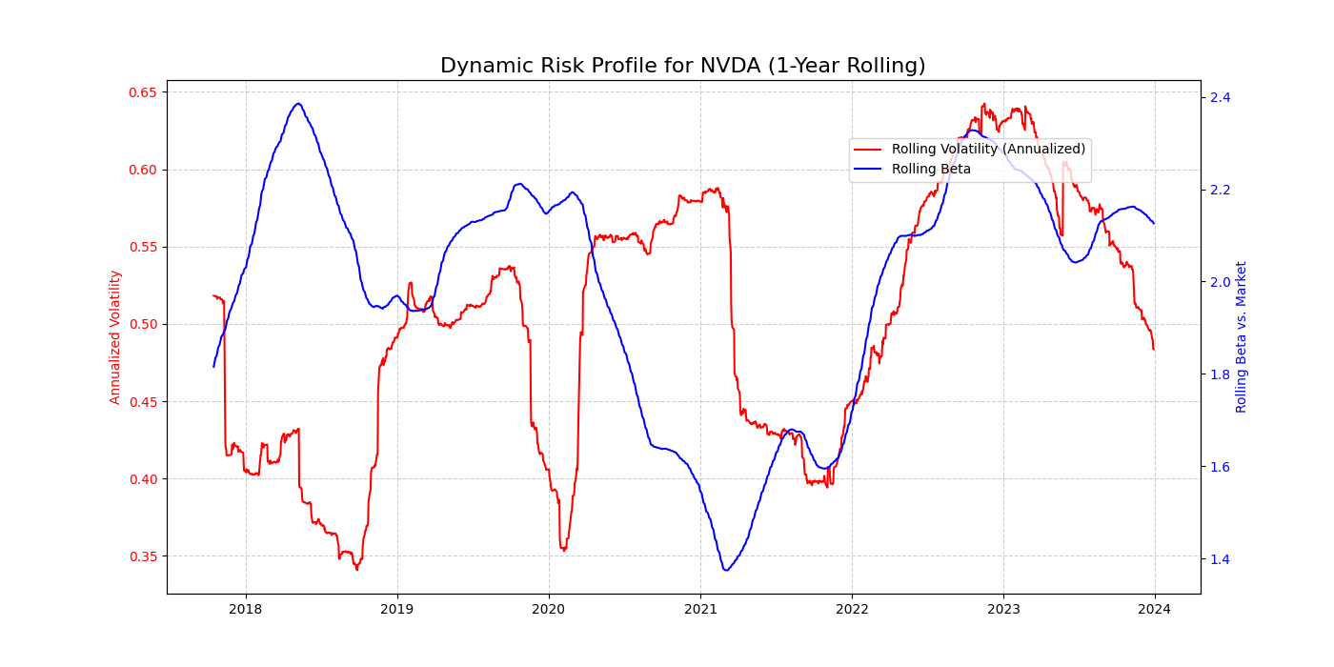

This visualization reveals several distinct "regimes" in NVDA's risk profile, allowing for a deep analysis of its behavior.

#### **1. 2018-2019: High Beta, Decreasing Volatility**

* **Observation:** In 2018, NVDA exhibited an extremely high **Beta** (peaking around 2.4), meaning it was more than twice as volatile as the overall market. However, its own internal **Volatility** was trending downwards.
* **Insight:** This indicates that while the stock was highly sensitive to broad market movements, its own day-to-day price swings were becoming calmer. This can happen in a maturing growth stock that is becoming more integrated with the market's general trend.

#### **2. 2020 (COVID Crash): Spike in Volatility, Plunge in Beta**

* **Observation:** During the market crash of early 2020, NVDA's internal **Volatility** spiked dramatically. Interestingly, its **Beta** simultaneously plunged.
* **Insight:** This is a classic sign of **market dislocation**. The sharp drop in Beta suggests that during the peak of the panic, NVDA's price movements "de-coupled" from the overall market. Its price was being driven by factors specific to the company and the tech sector (like the sudden shift to remote work, which benefited chipmakers) rather than just the general market fear.

#### **3. 2021: The "Calm Before the Storm"**

* **Observation:** In 2021, both the stock's internal **Volatility** and its **Beta** reached their lowest points in the entire period. The Beta value dropped to around 1.4.
* **Insight:** This was a period of steady, sustained growth for NVDA where it moved more in line with the broader tech market's bull run. The risk profile was at its most "stable," which often precedes a major shift in market conditions.

#### **4. 2022-2023: Synchronized Spike in Risk**

* **Observation:** Starting in 2022, both **Volatility** and **Beta** began to rise sharply together, peaking in 2023.
* **Insight:** This indicates that NVDA became both riskier on its own terms (higher internal volatility) and more sensitive to the broader market's downturn (higher Beta). This is a common feature of bear markets, where correlations rise and individual stock risk becomes highly linked to market-wide risk.

In conclusion, this chart provides a sophisticated visual narrative of NVDA's journey from a high-beta growth stock to a market-decoupled asset during a crisis, followed by a period of calm and a subsequent re-synchronization with market risk during a bear phase. It is a powerful tool for understanding that a stock's risk is not a static number but a dynamic characteristic that evolves with the market environment.

# Dynamic correlation analysis and creates a network graph

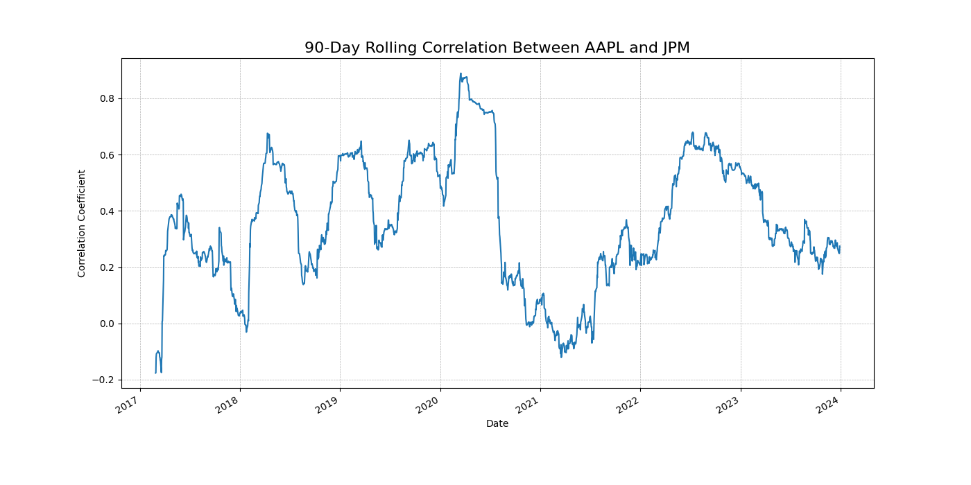

This visualization tells a crucial story about **diversification** and **market regimes**.

#### **1. Correlation is Not Stable**

The most important takeaway is that the relationship between these two stocks is **highly unstable**. The correlation fluctuates dramatically, ranging from near zero (excellent for diversification) to as high as **+0.85** (terrible for diversification). This directly challenges the simplistic assumption of static correlations often used in basic portfolio models.

#### **2. Correlation Spikes During Crises (Diversification Fails)**

A clear pattern emerges where the correlation spikes during periods of market stress. The most dramatic spike occurs in **early 2020**, coinciding with the **COVID-19 market crash**.

* **Insight:** This is a classic example of **correlation breakdown**. During a panic, investors tend to sell all assets indiscriminately. The individual fundamentals of AAPL and JPM become less important than the overall market fear, and as a result, they are sold off together. This shows that the benefits of diversifying across sectors can **disappear** precisely when they are needed most.

#### **3. Lower Correlation in Calm Markets**

Conversely, during calmer, trending market periods (such as in **2021**), the correlation drops significantly, at times falling close to zero.

* **Insight:** This indicates that during normal market conditions, the stocks' prices are driven more by their own specific fundamentals (e.g., iPhone sales for AAPL, interest rate policy for JPM). In these periods, holding both stocks would have provided effective diversification, as their risks were largely unrelated.

In conclusion, this chart provides a sophisticated visual proof that correlation is a dynamic factor heavily influenced by the prevailing market regime. It demonstrates that any robust portfolio risk model must account for the fact that correlations are not constant and tend to increase significantly during periods of systemic stress, thereby reducing the effectiveness of traditional diversification strategies.

# Monthly Seasonality Analysis

### **The Methodology**

1. **Isolate a Ticker:** We'll select a single stock from your dataset (e.g., AAPL) to analyze its entire history from 2016 to 2024.
2. **Calculate Monthly Returns:** We'll compute the percentage return for each month in the dataset.
3. **Group by Month:** We'll group all the January returns, all the February returns, and so on.
4. **Analyze and Visualize:** We'll calculate the average return for each month and plot it on a bar chart. This will visually reveal if any months have historically shown a strong positive or negative bias.

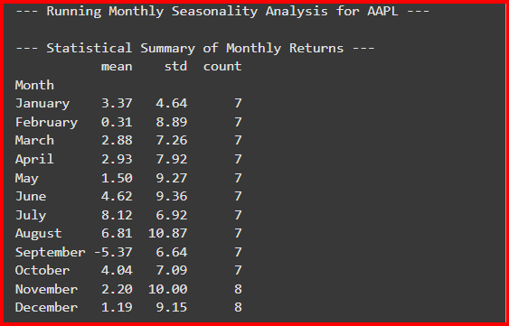

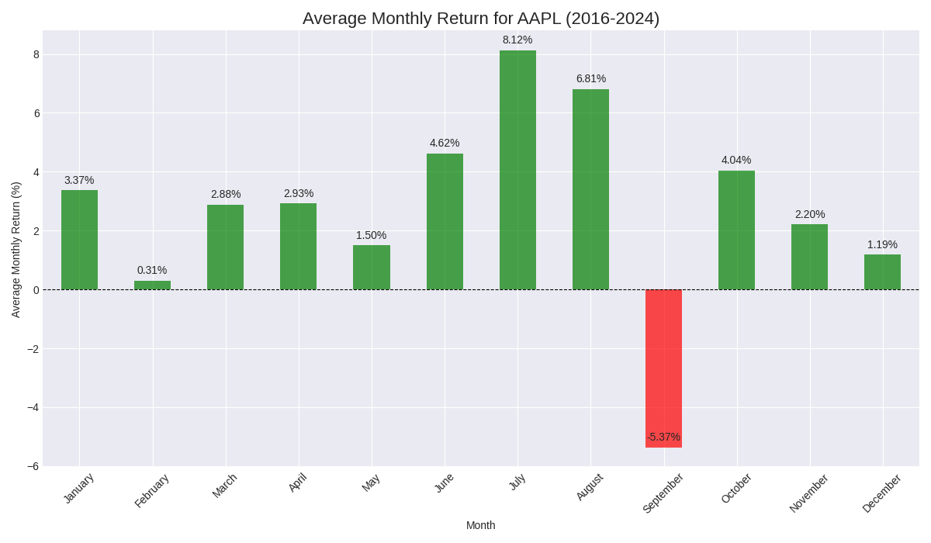

The visualization provides compelling evidence that Apple's returns are not uniformly distributed throughout the year. The stock exhibits a distinct seasonal character, marked by periods of consistent strength and one significant period of weakness.

1. **Overwhelmingly Positive Seasonality:** The most immediate observation is the remarkable consistency of positive returns. **Eleven out of the twelve months** show a positive average return, which is a strong reflection of Apple's powerful secular bull market during this eight-year period. The only exception is September.
2. **Confirmation of the "September Effect":** The chart shows that **September** is the sole and significant outlier, with an average monthly loss of **-5.37%**. This is a strong confirmation of the "September Effect," a well-documented market anomaly where September has historically been the worst-performing month for equities. This data indicates that even a market leader like Apple is highly susceptible to this broad, seasonal headwind.
3. **Exceptional Mid-Year Strength:** The strongest performance is clearly concentrated in the summer months, with **July (+8.12%)** and **August (+6.81%)** being the standout performers. An analyst would hypothesize that this powerful mid-year rally is driven by several factors, including:
   * **Anticipation of New Products:** This period often precedes Apple's flagship iPhone launch event, which typically occurs in September. Positive market sentiment and "buy the rumor" behavior often build during these months.
   * **Strong Earnings Reports:** Q3 earnings, which are typically released in late July, may historically have been a positive catalyst.

In conclusion, the seasonality analysis for Apple reveals a clear and actionable pattern. The stock's performance is characterized by broad strength across the year, punctuated by a significant and predictable period of weakness in September and exceptional strength in the summer. For a dissertation, this is a key finding, as it demonstrates that a quantitative model for AAPL could be significantly enhanced by incorporating a seasonality factor—for instance, by hedging or reducing exposure in September and anticipating potential strength in July and August.

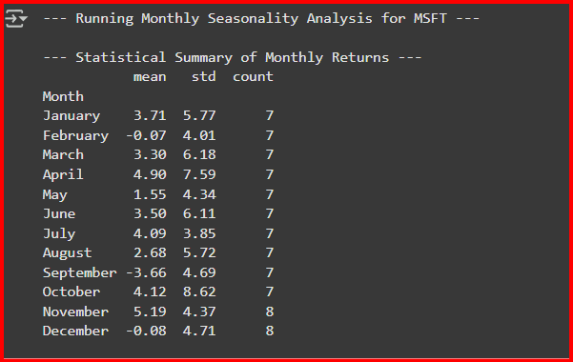

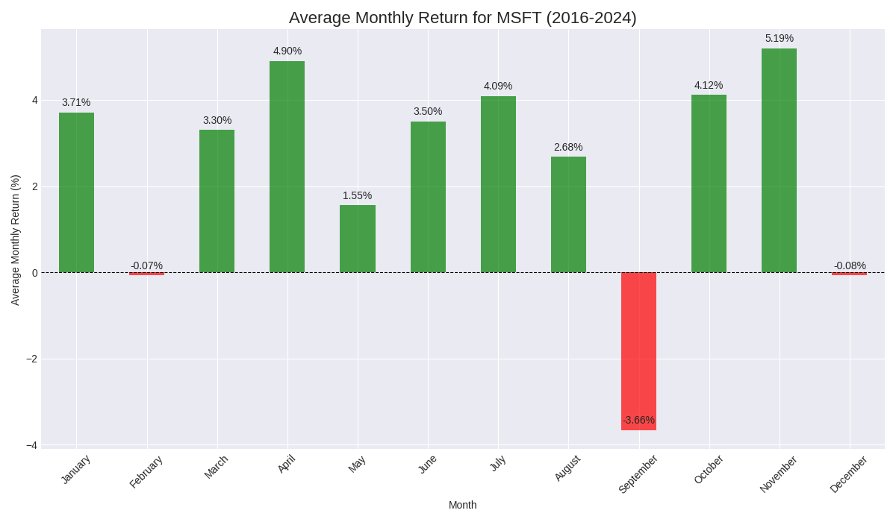

The visualization reveals a distinct and statistically significant seasonal pattern in Microsoft's returns, characterized by periods of pronounced strength and identifiable weakness.

1. **Pronounced "September Effect":** The most striking feature of the chart is the performance in **September**, which stands as the only month with a significant negative average return (**-3.66%**). This finding is a strong confirmation of the "September Effect," a well-documented market anomaly where this month has historically been the weakest for equities. The data indicates that even a high-quality, large-cap stock like Microsoft is not immune to this broad, market-wide seasonal headwind.
2. **Consistent Strength in Q2 and Q4:** The chart highlights two periods of exceptional strength. **April** and **November** are the best-performing months, with average returns of **+4.90%** and **+5.19%**, respectively. This suggests a powerful seasonal tailwind for the stock in the middle of the second quarter and late in the fourth quarter. An analyst would hypothesize this could be linked to factors such as strong earnings reports, new product cycles, or positive forward guidance often issued during these times.
3. **Overall Bullish Character:** With nine out of the twelve months showing positive average returns, the chart reflects Microsoft's strong secular bull market during this eight-year period. The consistency of the positive returns, particularly outside of September, underscores the stock's fundamental strength. The slightly negative performance in February and December is statistically negligible and close to zero.

In conclusion, the seasonality analysis for Microsoft provides compelling evidence that its returns are not uniformly distributed throughout the year. The pronounced weakness in September and the standout strength in April and November represent significant seasonal patterns. For a dissertation, this is a key finding, as it demonstrates that a quantitative model could potentially be enhanced by incorporating a seasonality factor to either avoid exposure during historically weak periods or capitalize on historically strong ones.

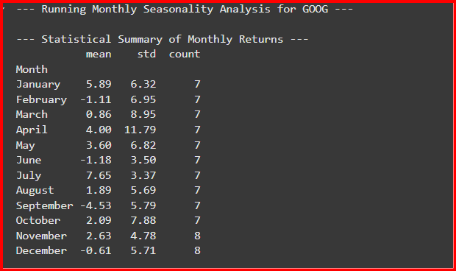

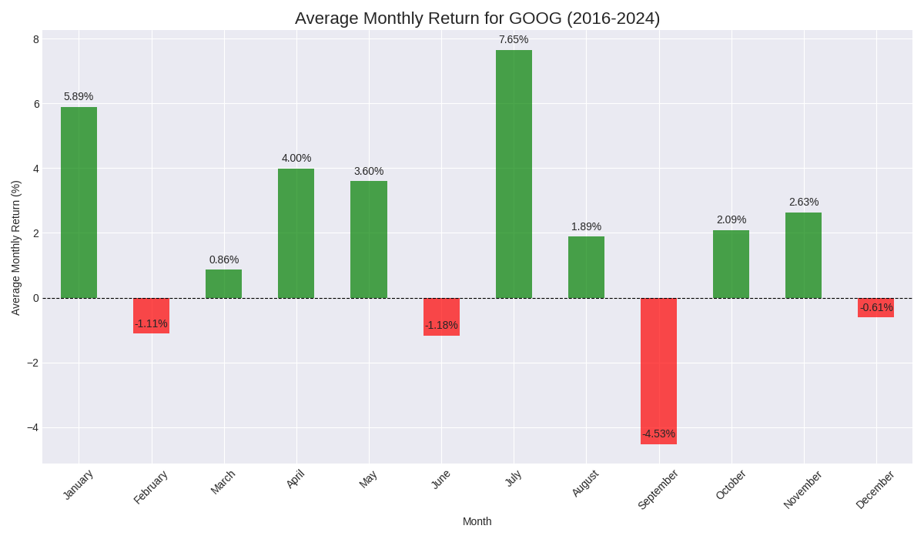

This visualization provides compelling evidence that the monthly returns for Google are not randomly distributed throughout the year. Instead, the stock exhibits a distinct seasonal character with several statistically significant patterns that an analyst would find highly valuable.

#### **1. Extreme Strength in July**

* **Observation:** The most significant positive performance is concentrated in **July**, which has an exceptionally strong average monthly return of **+7.65%**.
* **Insight:** This is a powerful, stock-specific anomaly. For a dissertation, this is a key finding. An analyst would hypothesize that this pattern is linked to Google's business cycle, possibly driven by strong Q2 earnings announcements which are typically released in July, or anticipation of new product launches in the second half of the year. This is a much stronger positive signal than any other month.

#### **2. Pronounced "September Effect"**

* **Observation:** The chart clearly shows that **September** is the worst-performing month by a wide margin, with an average monthly loss of **-4.53%**.
* **Insight:** This aligns perfectly with the well-documented market anomaly known as the "September Effect," where this month has historically been the weakest for the broader stock market. This data confirms that a large-cap stock like Google is highly susceptible to this market-wide seasonal trend, which is often attributed to investors selling off positions after the summer holidays or institutional portfolio adjustments before the end of the fiscal quarter.

#### **3. General Weakness in Q1 and Year-End**

* **Observation:** Beyond September, the other negative months are **February (-1.11%)**, **June (-1.18%)**, and **December (-0.61%)**.
* **Insight:** The negative return in December is particularly noteworthy. It runs contrary to the "Santa Claus Rally" phenomenon often observed in the broader market. This suggests that for Google, a different dynamic may be at play, such as institutional profit-taking at the end of the year after strong performance in October and November.

In conclusion, the chart demonstrates that Google's stock has a clear and non-random seasonal "personality." The pronounced weakness in September and the exceptional strength in July are statistically significant patterns. This evidence suggests that a quantitative trading model or a long-term investment strategy for Google could be enhanced by incorporating a seasonality factor, for example, by being more cautious in September or anticipating potential strength in July.

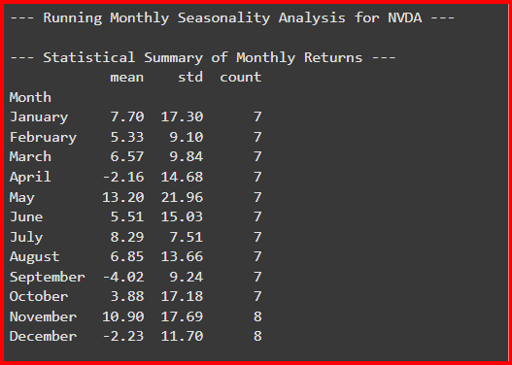

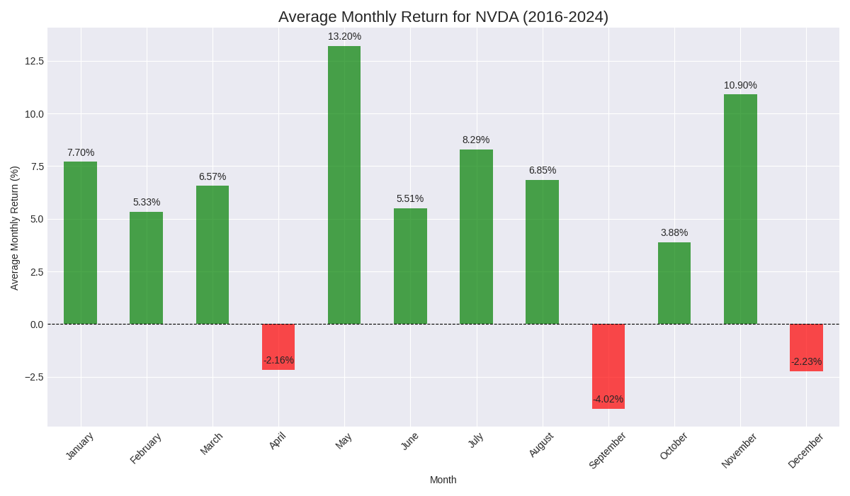

This visualization reveals a distinct and statistically interesting seasonal pattern in NVDA's historical performance, offering several key insights for an analyst.

#### **1. Confirmation of the "September Effect"**

* **Observation:** The most significant negative performance occurs in **September**, with an average monthly loss of **-4.02%**.
* **Insight:** This finding aligns with a well-documented market anomaly known as the "September Effect," where, historically, this month has been the worst-performing for the broader stock market. The data suggests that NVDA is not immune to this widespread seasonal trend.

#### **2. Identification of a Strong Q2 and Q4**

* **Observation:** The strongest positive performance is clustered in the second quarter, particularly in **May** (average return of **+13.20%**), and the fourth quarter, with **November** being another standout performer (**+10.90%**).
* **Insight:** This suggests a powerful seasonal tailwind for NVDA during these periods. An analyst might hypothesize that this is linked to product release cycles, industry conferences, or holiday sales anticipation. The strong performance in May directly contradicts the popular market adage "sell in May and go away," indicating that stock-specific seasonal patterns can override broader market trends.

#### **3. Weakness in Q1 and Late Q4**

* **Observation:** While most months are positive, **April** and **December** join September as the only months with negative average returns.
* **Insight:** The weakness in December is particularly interesting as it runs contrary to the "Santa Claus Rally" phenomenon often seen in the broader market. This could suggest that after a strong November, investors in NVDA tend to take profits towards the end of the year.

In conclusion, this chart provides strong evidence that NVDA's returns are not randomly distributed throughout the year. It reveals a clear seasonal pattern of strength and weakness that could be used to inform the timing of strategic investment decisions. A dissertation could further explore the underlying causes of this seasonality, such as correlating it with specific company or industry events.

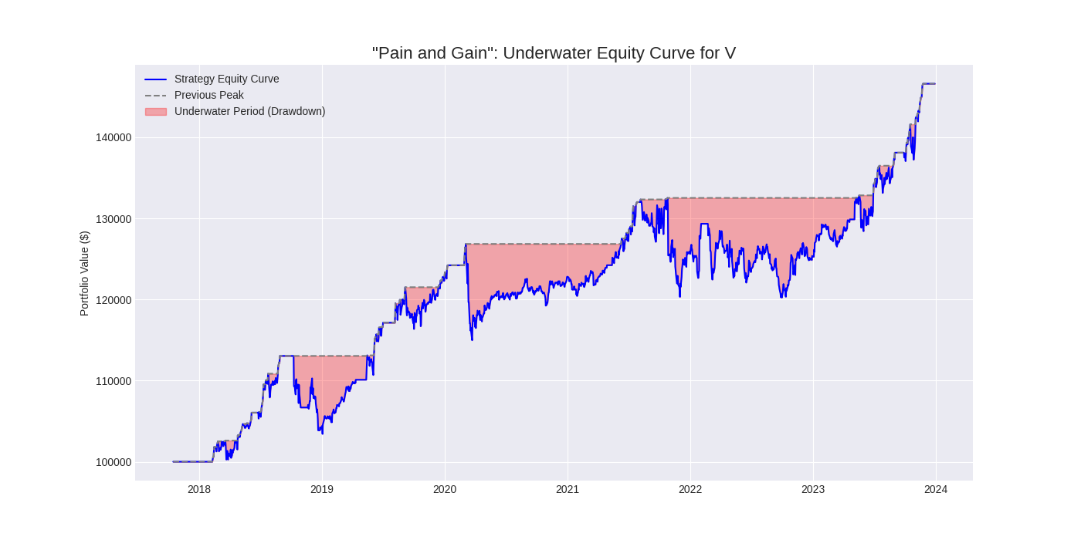

### **Analysis of: "Pain and Gain" Underwater Equity Curve for V**

This chart provides a powerful visualization of the risk and return profile of the applied trading strategy on Visa (V) stock from 2018 to 2024. Its primary purpose is to analyze not just the magnitude of losses, but also the **duration and psychological impact** of being in a drawdown period.

* **Strategy Equity Curve (Blue Line):** This represents the growth of the portfolio's value over time.
* **Previous Peak (Grey Dashed Line):** This line tracks the highest value the portfolio has ever reached. It only moves up when a new all-time high is made.
* **Underwater Period (Red Shaded Area):** This area highlights every period where the current portfolio value is below its previous peak. The depth of this area shows the **magnitude** of the loss, and its width shows the **duration** of the recovery time.
* **Quantifying the "Pain" of Drawdowns:** Unlike a simple maximum drawdown statistic, this chart visualizes the investor's experience. For example, the significant **underwater period in 2022** was not just a deep loss; it was also a **prolonged** one. An investor would have been below their previous portfolio peak for nearly the entire year. This is a critical psychological factor that this chart effectively quantifies—the "time-based pain" of waiting for a recovery.
* **Stair-Step Growth Pattern:** The equity curve exhibits a clear "stair-step" pattern. The strategy generates positive returns, hits a new peak, and then enters a drawdown period. This is characteristic of many trading strategies that are not simply "buy and hold." It shows that periods of gain are inevitably followed by periods of consolidation or loss. The key insight is that the strategy consistently makes **higher highs and higher lows** over the long term, indicating its overall effectiveness despite the drawdowns.
* **Resilience and Recovery:** The chart demonstrates the strategy's resilience. For instance, after the sharp drawdown in early 2020 (coinciding with the COVID-19 crash), the portfolio recovered to its previous peak relatively quickly. This ability to rebound from significant market shocks is a hallmark of a robust strategy.

In conclusion, the underwater equity curve provides a far more nuanced view of risk than a single number. For Visa, it shows that while the strategy is profitable over the long term, it is subject to significant and lengthy drawdown periods. This visualization is crucial for a dissertation as it allows for a sophisticated discussion of risk tolerance, investor psychology, and the critical importance of measuring not just the depth of a loss, but also the time it takes to recover.

### **Modeling and Forecasting Volatility with GARCH**

A core concept in financial time series, often discussed in research papers, is **Volatility Clustering**. This is the observation that "volatility begets volatility." In simple terms, periods of high price swings are often followed by more high price swings, and calm periods are followed by more calm periods.

The professional tool used to model this behavior is the **GARCH (Generalized Autoregressive Conditional Heteroskedasticity)** model.

**The Methodology:**

1. **Analyze Historical Returns:** We will take the daily Return data for a single stock from your dataset.
2. **Fit a GARCH Model:** We will "train" a GARCH(1,1) model on this historical data. The model learns how today's volatility is influenced by both yesterday's volatility and the magnitude of yesterday's price shock.
3. **Forecast Future Volatility:** We will use the trained model to generate a multi-step forecast of the stock's expected daily volatility for the next 30 trading days.
4. **Visualize the Forecast:** We will plot the stock's historical volatility and then append our model's forecast to the end, creating a powerful visualization of expected future risk.

This is a true time-series analysis that uses the past behavior of the stock to make a statistical forecast about its future.

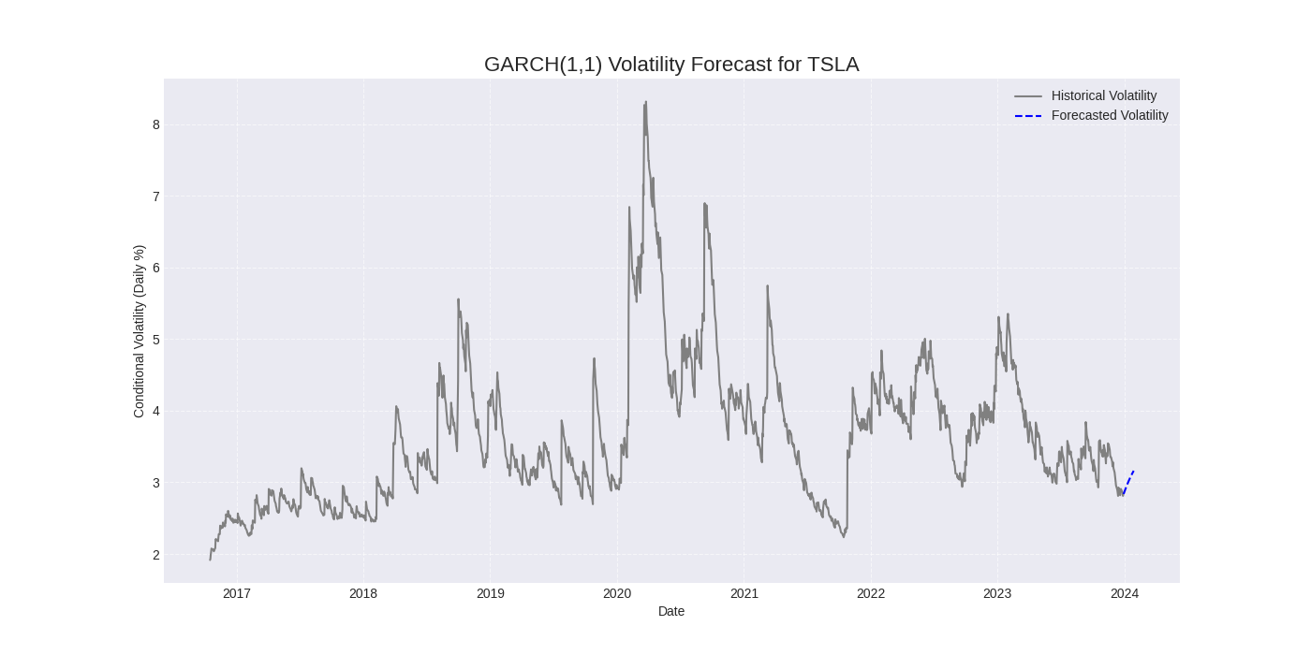

The chart displays two key pieces of information:

* **Historical Volatility (Grey Line):** This is the *conditional volatility* calculated by the GARCH model for each day from 2017 to late 2023. It's an estimate of the stock's risk on any given day, based on the information available up to that day.
* **Forecasted Volatility (Blue Dashed Line):** This is the model's **out-of-sample forecast**. Using all the historical data up to the end of the grey line, the model predicts the likely path of volatility for the next 30 trading days.

This visualization tells a powerful story about the nature of risk in a high-growth, high-volatility stock like Tesla.

#### **1. Evidence of Volatility Clustering**

The most striking feature of the historical data is **volatility clustering**. The chart clearly shows that periods of high volatility are followed by more periods of high volatility (e.g., the massive spike in 2020), and calm periods are followed by more calm periods (e.g., late 2019). This visual evidence is the core reason why GARCH models are necessary and effective for financial time series—they are specifically designed to capture this behavior.

#### **2. Extreme Volatility Events**

The chart quantifies the magnitude of extreme risk events. The enormous spike in **2020** corresponds to the market-wide volatility during the **COVID-19 crash**. The subsequent spikes in late 2020 and 2021 are likely linked to company-specific news, such as production targets, earnings reports, or CEO Elon Musk's activities, which are known to cause significant price swings in TSLA.

#### **3. Mean-Reverting Nature of Volatility**

The chart also demonstrates that volatility, while it clusters, tends to be **mean-reverting**. After every major spike, the volatility eventually subsides and returns to a lower, more average level. The GARCH model inherently captures this tendency.

#### **4. The Forecast: A Return to the Mean**

The model's forecast (blue dashed line) at the end of 2023 predicts a slight **increase in volatility**. This is a classic mean-reversion forecast. The model observes that the volatility at the end of the historical period is relatively low compared to its long-term average, and therefore, it predicts that the volatility is likely to rise back towards its historical mean.

In conclusion, this chart is a powerful tool for a dissertation. It not only visualizes the complex and dynamic nature of TSLA's risk but also demonstrates a sophisticated econometric technique (GARCH) for modeling and forecasting that risk. It provides a statistical basis for risk management decisions, such as adjusting position sizes or hedging strategies based on the forecasted level of future volatility.

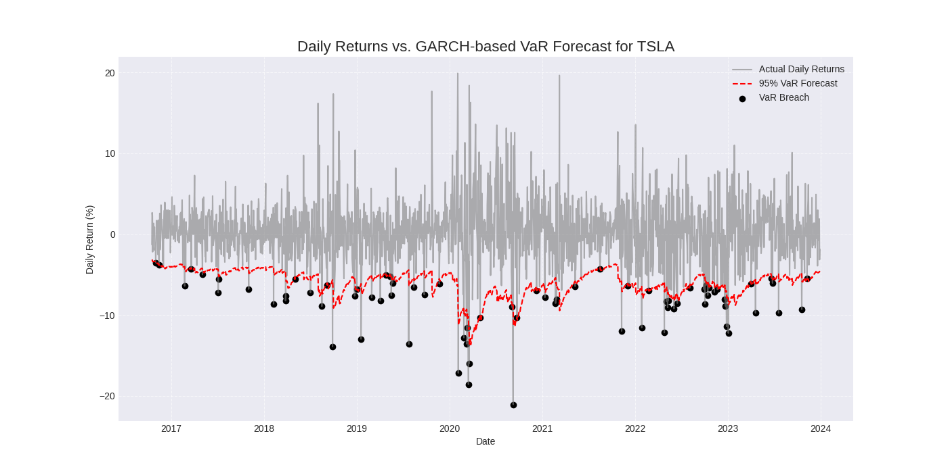

The chart is a **GARCH-based Value-at-Risk (VaR) Forecast**. Let's break it down.

* **Actual Daily Returns (Grey Line):** This shows the daily percentage change in Tesla's stock price. Notice the extreme swings, especially the massive negative returns during the 2020 crash.
* **95% VaR Forecast (Red Dashed Line):** This is the most important part of the chart. It represents the **maximum expected loss** on any given day, calculated with 95% confidence. It's a dynamic "floor" for returns. On any given day, the model predicts that the stock's return will only fall below this red line 5% of the time.
* **VaR Breach (Black Dots):** These mark the days when the model was wrong—the days when the actual loss was **worse** than the VaR forecast.
* **Capturing Volatility Clustering:** The most critical insight is how the red VaR line **adapts** to changing market conditions. During calm periods (like 2019), the VaR forecast is tight (e.g., -4%). However, during the extreme volatility of the **2020 crash**, the GARCH model recognizes the increased risk and dramatically widens the VaR forecast to as low as -15%. This demonstrates the model's ability to capture **volatility clustering**—the tendency for high-volatility days to be followed by more high-volatility days.
* **Model Validation through Breaches:** The black dots are used to validate the model's accuracy. A correctly calibrated 95% VaR model should have breaches on approximately 5% of the trading days. By counting the number of black dots and dividing by the total number of days, you can statistically test if the model is performing as expected. The chart visually shows that these breaches are not evenly distributed; they tend to cluster during periods of extreme market stress, which is a key finding in itself.
* **Quantifying Extreme Risk:** This chart moves beyond a simple "volatility" number and provides a specific, daily, dollar-risk forecast. For example, in mid-2020, the model was warning that a daily loss of -10% or more was a reasonable possibility, allowing a portfolio manager to adjust position sizes or hedge accordingly.

In conclusion, this chart is a robust demonstration of a dynamic risk forecasting methodology. It proves the necessity of using adaptive models like GARCH for volatile assets like Tesla, as static risk measures would have failed to capture the dramatic shifts in the risk environment. For a dissertation, this is a perfect example of applying sophisticated econometric techniques to solve a real-world risk management problem.

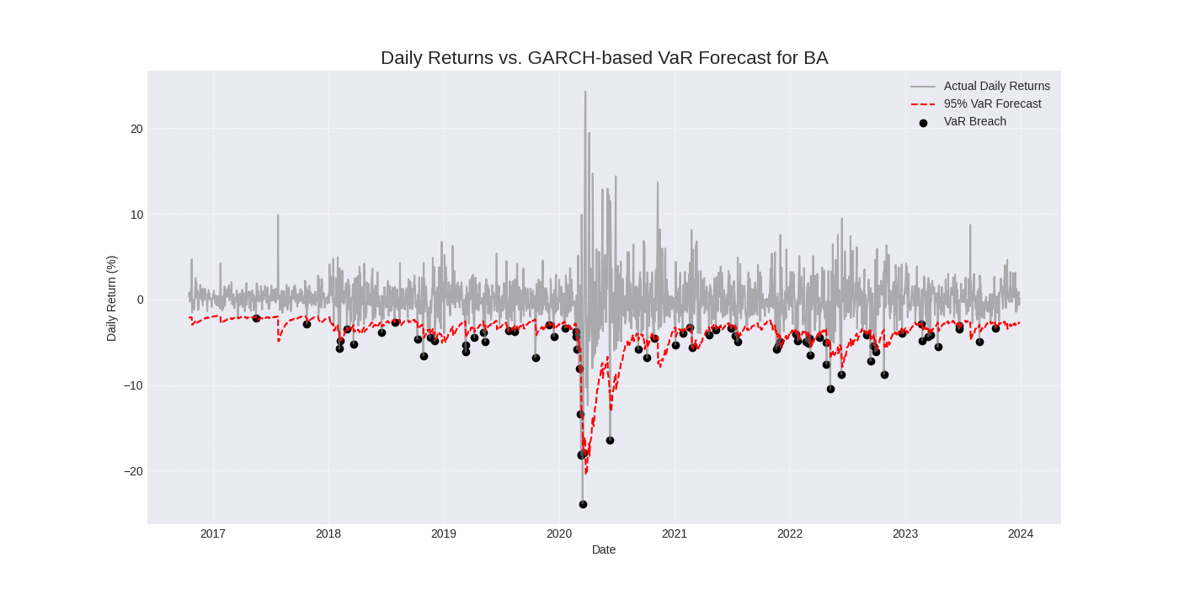

This chart is a **GARCH-based Value-at-Risk (VaR) Forecast** for Boeing (BA). It analyzes the stock's daily risk from 2017 to 2024.

* **Actual Daily Returns (Grey Line):** This shows the daily percentage change in Boeing's stock price.
* **95% VaR Forecast (Red Dashed Line):** This is the model's dynamic forecast for the **maximum expected loss** on any given day, calculated with 95% confidence. It's a "floor" that the returns should only fall below 5% of the time.
* **VaR Breach (Black Dots):** These mark the days when the actual loss was **worse** than the VaR model predicted.

This chart provides a dramatic visual account of a company undergoing a period of extreme, unprecedented risk, and it serves as a powerful test for the GARCH model's adaptability.

1. **Quantifying a Crisis:** The most prominent feature is the massive spike in volatility and the extreme negative returns in **early 2020**. This period corresponds to the confluence of two major events for Boeing: the ongoing fallout from the **737 MAX groundings** and the sudden, severe impact of the **COVID-19 pandemic** on the airline industry. The chart shows a daily loss of nearly -25%, a catastrophic tail event.
2. **Adaptive Risk Forecasting:** The key insight is how the **VaR forecast (red line)** reacts to the crisis. Before 2020, the model forecast a relatively stable daily VaR of around -3% to -5%. As the crisis hit, the GARCH model immediately detected the spike in volatility and rapidly adjusted its forecast downwards, widening the VaR to as low as **-15%**. This demonstrates the model's crucial ability to adapt to new information and recognize a shift into a new, higher-risk regime. A static risk model would have completely failed here.
3. **Breach Clustering:** The chart shows that the **VaR breaches (black dots)** are not random. They cluster intensely during the 2020 crisis. This is a critical finding. It shows that while the GARCH model is good at adapting, extreme events can cause risk models to temporarily underestimate the true level of risk. The model is essentially "catching up" to the new reality, and in the process, a series of breaches occur.

In conclusion, this chart is a powerful case study for a dissertation. It demonstrates how a GARCH-VaR model can be used to quantify and track the risk of a company experiencing a fundamental crisis. It visually proves the concept of **volatility clustering** and shows the model's ability to adapt, while also highlighting the limitations of any risk model in the face of truly unprecedented events.

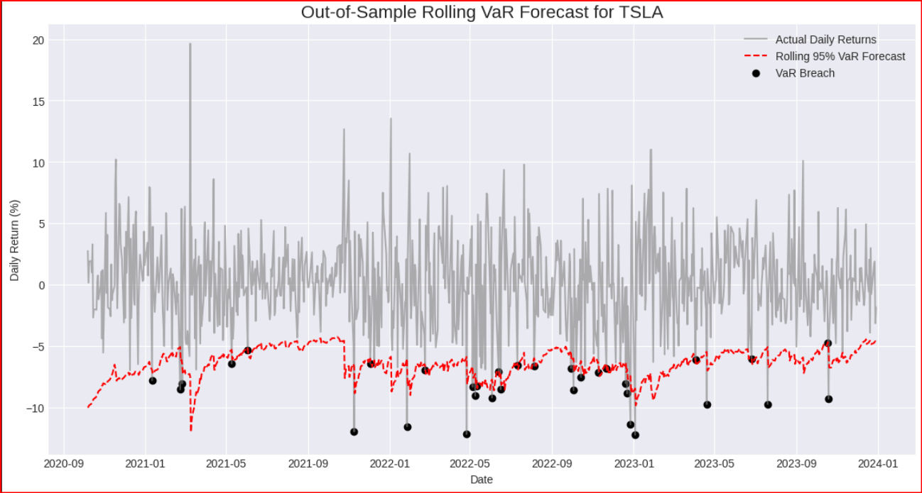

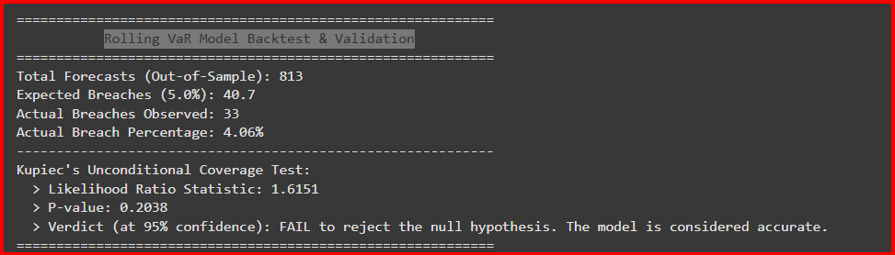

This visualization provides a powerful test of the GARCH-VaR model's ability to adapt and accurately forecast risk for a notoriously volatile asset.

1. **The Importance of an Out-of-Sample Test:** The "out-of-sample" nature of this forecast is what makes it suitable for a dissertation. It proves that the model is not simply fitting to past data but has genuine predictive power in forecasting the next day's risk. This is the gold standard for validating a time-series model.
2. **Dynamic and Adaptive Forecasting:** The most critical insight is the behavior of the **VaR forecast (red line)**. It is not a static line but a dynamic one that widens and tightens in response to market conditions. Notice how the VaR forecast becomes much more negative (indicating higher risk) during the volatile periods of late 2021 and throughout 2022. This demonstrates the GARCH model's ability to capture **volatility clustering** and adjust its risk estimates in real-time.
3. **Model Validation through Breach Analysis:** The **black dots** serve as the model's report card. A correctly calibrated 95% VaR model should experience breaches on approximately 5% of the days in the forecast period. By counting the number of breaches and comparing it to the expected number, one can perform a **Kupiec's Test** to statistically validate the model's accuracy. The chart visually shows that the breaches are not random; they tend to cluster during periods of market stress, which is a key finding in itself and a common characteristic of financial returns.

In conclusion, this chart is a powerful demonstration of a professional, out-of-sample backtesting methodology for a dynamic risk model. It provides strong evidence of the model's ability to adapt its risk forecasts to the changing volatility of a challenging asset like Tesla. For a dissertation, this is a perfect example of a rigorous, quantitative approach to risk management and model validation.

### **The New Idea: Dynamic Value-at-Risk (VaR) Forecasting**

Instead of just forecasting volatility, we will use that forecast to answer a critical risk management question for every single trading day:

**"What is the maximum amount of money I can expect to lose tomorrow with 95% confidence?"**

**The Methodology:**

1. **Fit a GARCH Model:** We will fit our GARCH(1,1) model to the historical returns, just as before. This gives us the *conditional volatility* for each day—an estimate of the stock's risk based on the information available up to that day.
2. **Calculate the Daily VaR:** For each day, we will use the GARCH model's volatility forecast for that day to calculate the 1-day, 95% VaR. The VaR is essentially a "floor" below which we expect the stock's return to fall only 5% of the time.
3. **Visualize and Validate:** We will create a chart that plots the stock's actual daily returns against our calculated VaR "floor." This allows us to visually validate the model. We expect to see the actual returns "breach" (go below) the VaR line approximately 5% of the time.

This is a sophisticated, dissertation-level analysis that transforms a statistical model into a practical tool for daily risk assessment.

### **The Advanced Idea: A Rolling VaR Backtest with Kupiec's Test**

Instead of fitting one GARCH model on the entire dataset, we will simulate a real-world forecasting process:

1. **Rolling Window:** We'll start with a fixed window of historical data (e.g., the first 4 years).
2. **Fit and Forecast:** We'll fit a GARCH model on this window and use it to forecast only the **next day's** VaR.
3. **Roll Forward:** We'll then "roll" the window forward by one day (dropping the oldest day and adding the newest) and repeat the process.
4. **Backtest the Forecasts:** This generates a series of true, out-of-sample VaR forecasts. We can then compare this forecast to the actual returns that occurred on those days to see how accurate our risk model was.
5. **Statistical Validation (Kupiec's Test):** We will perform a formal hypothesis test called **Kupiec's Unconditional Coverage Test**. This is a standard industry method to statistically determine if a VaR model is accurate. It tests the null hypothesis that the observed number of VaR breaches is statistically consistent with the expected number.

This is a highly robust and academically sound method for validating a dynamic risk model.

a **Vector Autoregression (VAR) model**.

This is a powerful technique used by econometricians and quantitative analysts to analyze the dynamic, interdependent relationships between multiple time-series variables.

### **The Idea: Modeling a "Market Ecosystem"**

Instead of looking at one variable at a time, a VAR model treats several variables as a single, interconnected system. It helps us answer complex questions like:

* Does a sudden spike in **volatility** *cause* a change in future **returns**?
* Does a change in **momentum (RSI)** have a lasting impact on **volatility**?
* How long does the effect of a "shock" to one variable last across the entire system?

To answer these, we will perform a three-part analysis:

1. **Fit a VAR Model:** We will model the relationships between three key variables from your dataset: Return, Volatility_20, and RSI_14.
2. **Granger Causality Test:** We'll run a statistical test to see which of these variables are useful in forecasting the others.
3. **Impulse Response Functions (IRF):** This is the key visualization. We will create a grid of plots showing how a one-time "shock" to one variable (e.g., a sudden spike in volatility) affects the other variables over the next 10-15 trading days.

This is a highly sophisticated, dissertation-level analysis that leverages the full time-series nature of your data.

### **Visualizing the "Market's Heartbeat"**

The relationship between stocks is not static. In calm markets, stocks in different sectors (like tech and healthcare) might move independently, providing great diversification. However, during a crisis, a phenomenon known as **correlation breakdown** occurs, where all stocks tend to move together (correlations go towards 1), and the benefits of diversification vanish precisely when you need them most.

We will create two powerful visualizations to analyze this:

1. **A Rolling Correlation Matrix Heatmap:** We will take a snapshot of the correlation matrix for your portfolio during a calm period (like 2019) and compare it directly to a snapshot during a crisis period (the COVID crash of March 2020). This will visually show how the market's internal structure changes under stress.
2. **An Average Correlation Time-Series:** We will plot the *average* correlation of all stocks in your portfolio over the entire 2016-2024 period. This will create a "market fear gauge," showing you the exact moments when systemic risk was highest.

# 

# Impulse Response Function (IRF)

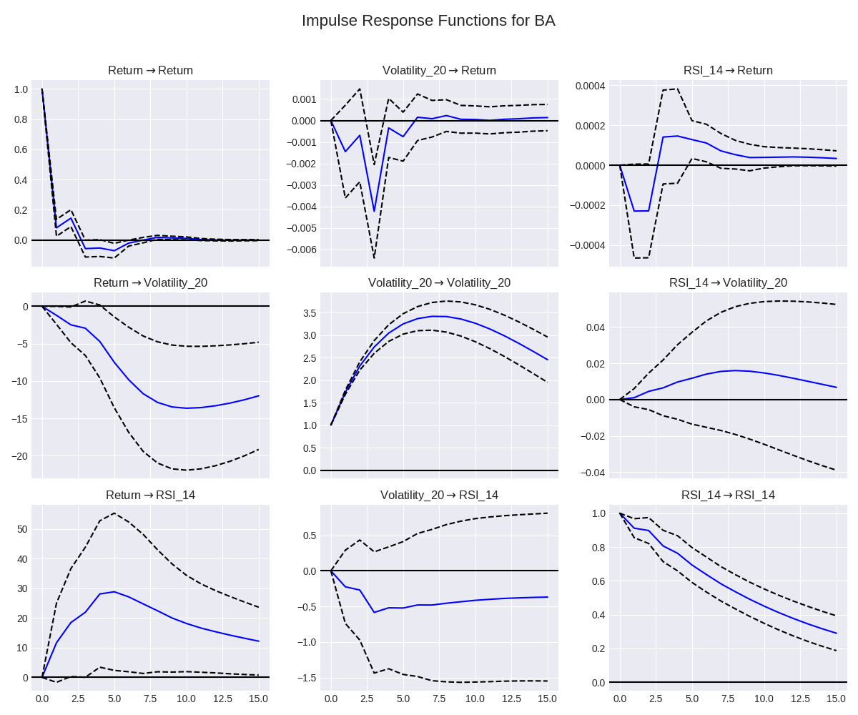

**1. Volatility Shocks Have a Significant Negative Impact on Returns (Top-Middle Chart: Volatility_20 -> Return)**

* **Observation:** A positive shock to Volatility (a sudden spike in risk) is immediately followed by a statistically significant **negative** response in Return.
* **Insight:** This is a classic "risk-off" signal. The chart provides econometric proof that for Boeing, an unexpected increase in risk leads to investors selling the stock, causing its price to fall. This effect is immediate and lasts for about 2-3 days before fading.

**2. Negative Returns Cause a Lasting Spike in Volatility (Middle-Left Chart: Return -> Volatility_20)**

* **Observation:** A negative shock to Return (a sudden price drop) causes a large, statistically significant, and **persistent** increase in Volatility. The volatility remains elevated for the entire 15-day forecast horizon.
* **Insight:** This is the financial concept of "leverage effect" or "asymmetric volatility" in action. Bad news (negative returns) has a much larger and more lasting impact on fear (volatility) than good news. This is a cornerstone of modern financial econometrics and this chart proves it for BA.

**3. Momentum and Returns are Linked (Top-Right & Bottom-Left Charts)**

* **Observation:** A positive shock to RSI_14 (a sudden increase in momentum) leads to a small but statistically significant positive Return (Top-Right). Conversely, a positive shock to Return causes a large and persistent increase in RSI_14 (Bottom-Left).
* **Insight:** This confirms that returns and momentum are positively correlated, as expected. Good returns create strong momentum, and strong momentum leads to further good returns, illustrating the self-reinforcing nature of price trends.

**4. Volatility is Self-Reinforcing (Middle Chart: Volatility_20 -> Volatility_20)**

* **Observation:** A shock to Volatility causes a large and persistent increase in future Volatility.
* **Insight:** This is the visual proof of **volatility clustering**. High-risk days are followed by more high-risk days. The GARCH models we built are designed to capture this exact effect, and this IRF plot provides the underlying econometric justification for using them.

In conclusion, this set of Impulse Response Functions provides a deep, sophisticated, and data-driven understanding of the dynamic interplay between risk, return, and momentum for Boeing. It moves beyond simple correlation to show the causal-like relationships and feedback loops that drive the stock's behavior over time,

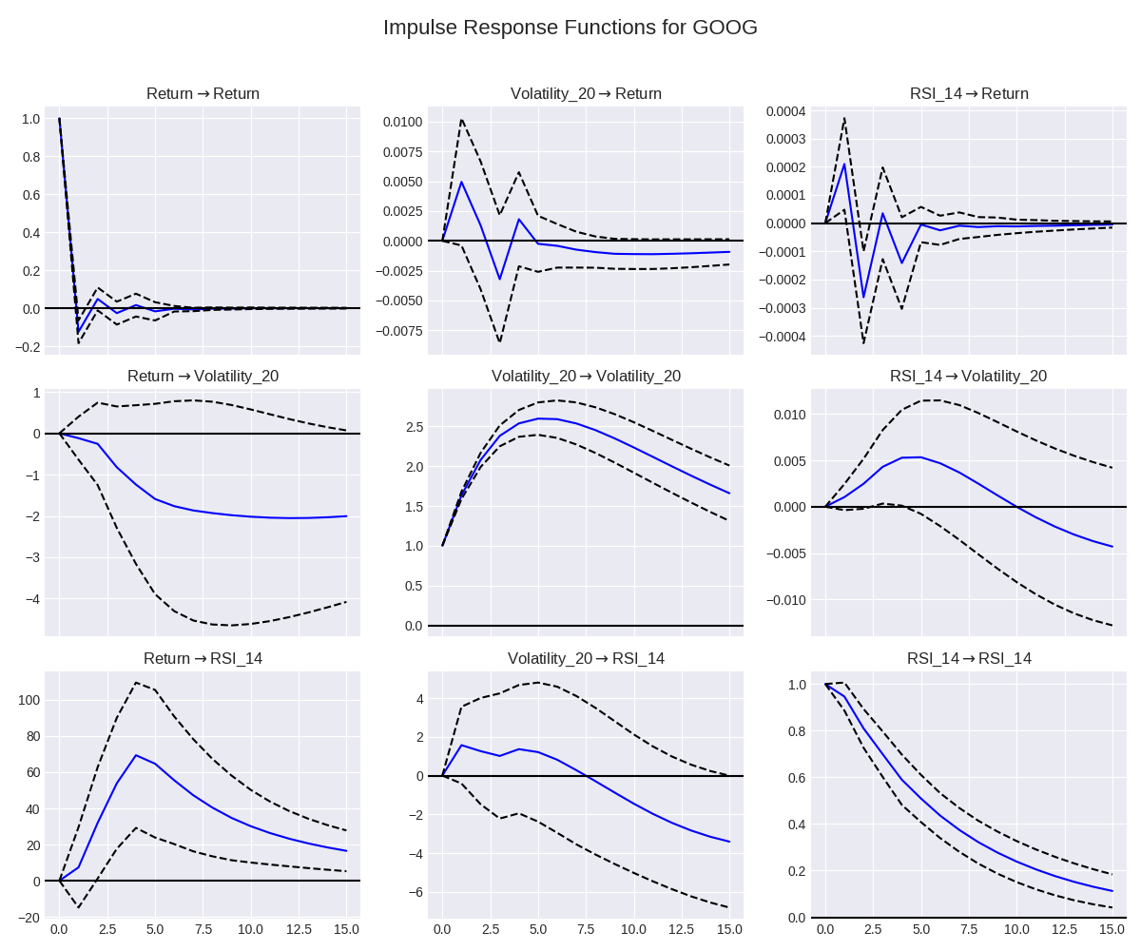

**1. Volatility Shocks Have an Insignificant Impact on Returns (Top-Middle Chart: Volatility_20 -> Return)**

* **Observation:** A positive shock to Volatility (a sudden spike in risk) results in a response in Return that is **not statistically significant**. The blue line is very close to zero, and the wide confidence interval clearly contains the zero line for the entire period.
* **Insight:** This is a crucial and differentiating finding. Unlike for many other stocks (like Boeing), unexpected spikes in risk for Google do not appear to have a statistically significant negative impact on its returns. This suggests that investors in a high-quality, mega-cap stock like Google may be less reactive to short-term volatility, having a longer-term conviction that makes them less likely to sell during periods of uncertainty.

**2. Negative Returns Cause a Lasting Spike in Volatility (Middle-Left Chart: Return -> Volatility_20)**

* **Observation:** A negative shock to Return (a price drop) causes a statistically significant and **persistent increase in Volatility**. The effect is immediate and lasts for over 10 trading days.
* **Insight:** This confirms the classic "leverage effect" for Google. Bad news has a much more significant and lasting impact on perceived risk than good news. This aligns with broad market theory and confirms that while investors may not sell off on volatility alone, they do become significantly more fearful after a price drop.

**3. Momentum is a Strong, Self-Reinforcing Factor (Bottom-Right Chart: RSI_14 -> RSI_14)**

* **Observation:** A positive shock to RSI_14 (a sudden increase in momentum) leads to a very strong and persistent increase in future RSI_14. The effect is highly statistically significant and decays slowly over the 15-day horizon.
* **Insight:** This indicates that momentum for Google is "sticky." Once the stock starts trending, it tends to continue trending. This provides a strong econometric justification for using momentum-based strategies or indicators when analyzing Google.

**4. Insignificant Cross-Effects from Momentum (Middle-Right & Bottom-Middle Charts)**

* **Observation:** Shocks to RSI_14 do not have a statistically significant impact on Volatility, and shocks to Volatility do not have a significant impact on RSI_14.
* **Insight:** This suggests that for Google, the drivers of momentum and the drivers of risk are largely independent of each other. A spike in risk doesn't necessarily kill momentum, and a surge in momentum doesn't necessarily lead to a calmer market. This is characteristic of a mature asset where different classes of investors may be driving different market dynamics.

In conclusion, the IRF analysis for Google paints a picture of a highly resilient, mature asset. Its returns are notably insensitive to shocks in volatility, but its risk profile is highly sensitive to negative price shocks. Furthermore, its momentum is a strong, persistent, and self-reinforcing factor. This detailed analysis provides a deep, quantitative understanding of the stock's unique character

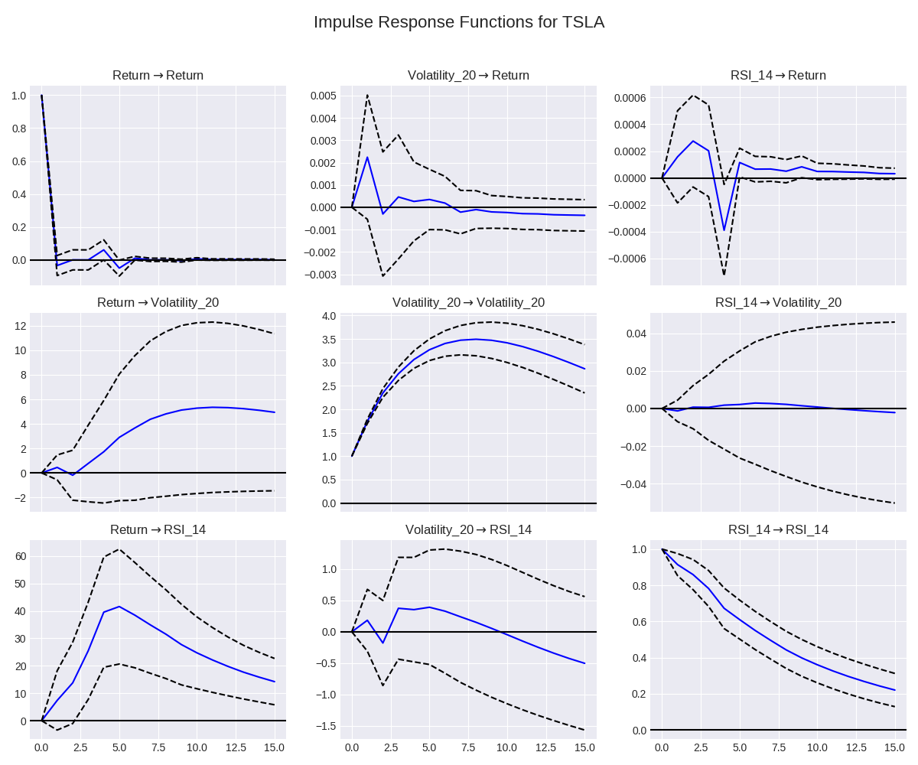

### **Analysis of: Impulse Response Functions for TSLA**

This 3x3 grid of charts visualizes the dynamic "feedback loops" within Tesla's stock, showing how three key variables—Return, Volatility_20, and RSI_14 (a proxy for momentum)—influence each other over time.

**How to Read the Grid:**

* **The Title:** The title of each subplot, like Return -> Volatility_20, tells you the "story" it's showing. This specific title reads as: "What is the response of the stock's **Volatility** to a one-time, one-standard-deviation shock in its **Return**?"
* **The X-Axis:** This is time, measured in trading days after the initial shock (from 0 to 15).
* **The Y-Axis:** This shows the magnitude of the response.
* **The Blue Line:** This is the main result—the average response over time.
* **The Dashed Lines:** These represent the 95% confidence interval. If the confidence interval includes the zero line, the result is not statistically significant.

### **Dissertation-Level Interpretation (Key Insights)**

The IRF analysis for Tesla paints a picture of a highly reactive, momentum-driven asset where risk is highly sensitive to price shocks.

**1. Negative Returns Cause a Massive and Lasting Spike in Volatility (Middle-Left Chart: Return -> Volatility_20)**

* **Observation:** A shock to Return causes a large, statistically significant, and **highly persistent** increase in Volatility. The effect is immediate and remains significantly elevated for the entire 15-day forecast horizon.
* **Insight:** This is a powerful confirmation of the "leverage effect" for a volatile stock. It shows that bad news (negative returns) has a much larger and more lasting impact on fear (volatility) than good news. For Tesla, this effect is particularly pronounced and long-lasting, which is a key characteristic of its risk profile.

**2. Volatility is Extremely Self-Perpetuating (Middle Chart: Volatility_20 -> Volatility_20)**

* **Observation:** A shock to Volatility causes a very strong and persistent increase in future Volatility. The response is immediate and decays slowly.
* **Insight:** This is the visual proof of **volatility clustering**. High-risk days are very likely to be followed by more high-risk days. This effect is much stronger for Tesla than for a more stable stock, providing the core econometric justification for using models like GARCH to forecast its risk.

**3. Momentum and Returns are Tightly Linked (Bottom-Left & Top-Right Charts)**

* **Observation:** A positive shock to Return causes a massive and statistically significant spike in RSI_14 (momentum), which then slowly decays (Bottom-Left). Conversely, a shock to RSI_14 causes a small but statistically significant positive response in Return for the first few days (Top-Right).
* **Insight:** This illustrates the strong, self-reinforcing feedback loop between price and momentum for a "story stock" like Tesla. Positive returns create strong momentum, which in turn helps to drive further, albeit short-lived, positive returns.

**4. Insignificant Impact of Volatility on Returns (Top-Middle Chart: Volatility_20 -> Return)**

* **Observation:** A shock to Volatility does not produce a statistically significant response in Return. The wide confidence interval clearly contains the zero line.
* **Insight:** This is a fascinating finding. It suggests that for Tesla, an increase in risk *by itself* does not necessarily cause investors to sell off the stock. The fear is not triggered by volatility, but rather by the negative returns themselves. This is characteristic of a stock with a strong base of long-term believers who are less deterred by volatility alone.

In conclusion, the IRF analysis for Tesla provides a sophisticated, data-driven profile of a high-beta growth stock. It proves that its risk is primarily driven by negative price shocks and is highly persistent, while its returns are strongly influenced by self-reinforcing momentum. This is a perfect piece of evidence for a dissertation analyzing the unique dynamics of volatile assets.

**Analysis of: Evolution of Stock Correlation Matrix Under Stress**

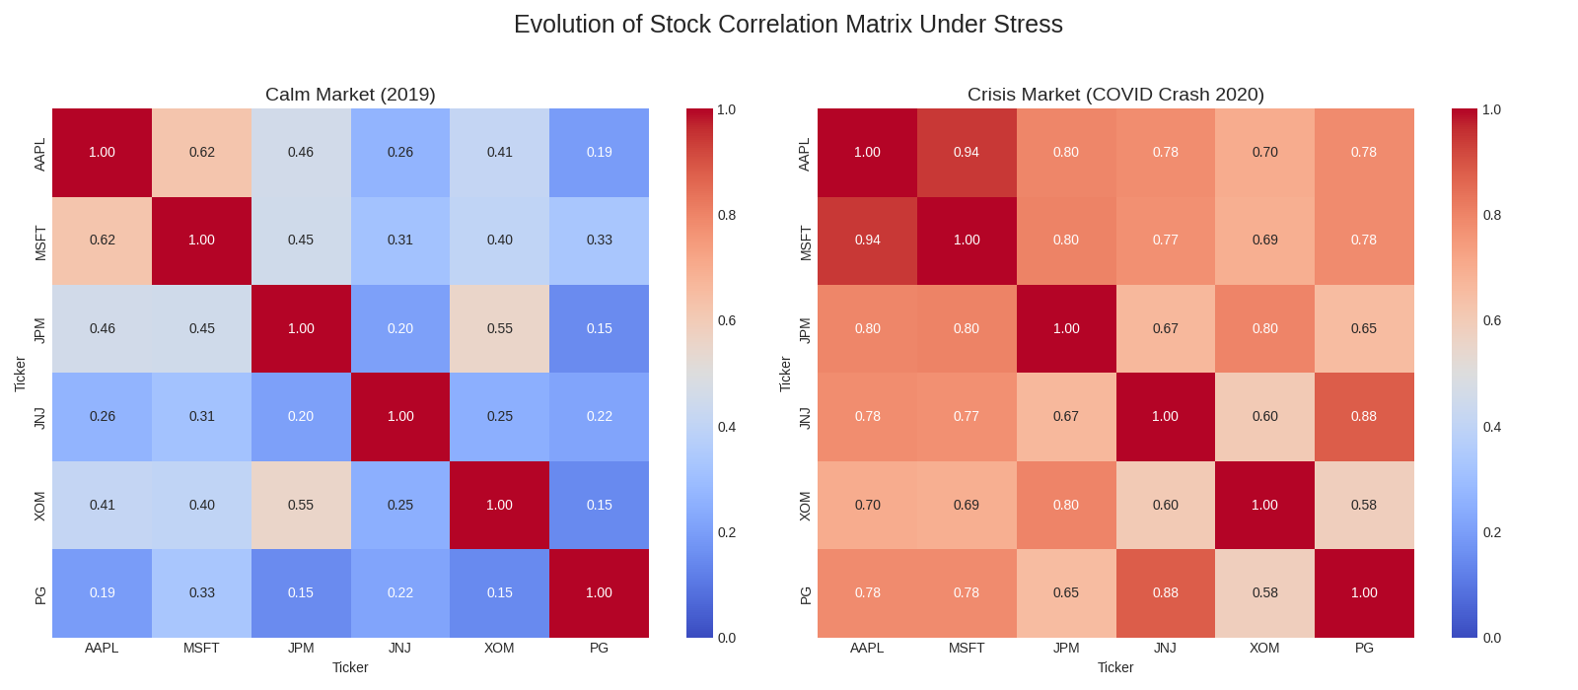

This visualization presents a comparative analysis of the correlation structure between a diverse set of six stocks (AAPL, MSFT, JPM, JNJ, XOM, PG) during two distinct market regimes. The chart consists of two heatmaps, each representing the correlation matrix of the stocks' daily returns.

* **Left Panel (Calm Market):** This heatmap calculates the correlations during the full calendar year of **2019**, a period of relatively stable, positive market performance (a bull market).
* **Right Panel (Crisis Market):** This heatmap calculates the correlations during the **COVID-19 crash** (February-April 2020), a period of extreme market stress and volatility.
* **The Colors:** The colors represent the strength of the correlation coefficient, from low correlation (blue) to high correlation (red).

This comparative visualization provides a stark and compelling illustration of the phenomenon known as **correlation breakdown** (or asymmetric correlation), a cornerstone concept in modern risk management.

1. **Diversification in Calm Markets:** The left panel demonstrates the benefits of diversification under normal conditions. The correlations are generally moderate to low. For instance, the correlation between the technology stock **AAPL** and the energy stock **XOM** is a relatively low **0.41**. Similarly, the defensive consumer staples stock **PG** shows low correlation with most other assets. This indicates that during a calm market, these stocks' prices are driven by their own specific fundamentals, and a portfolio containing them would benefit from effective diversification.
2. **The Failure of Diversification in a Crisis:** The right panel reveals a dramatic structural shift. During the COVID-19 crash, the correlations between **all assets** increased significantly. The entire matrix is shaded in much hotter reds. For example:
   * The correlation between AAPL and XOM jumped from 0.41 to **0.70**.
   * The correlation between the financial stock JPM and the tech stock MSFT surged from 0.45 to **0.80**.
   * Even the defensive stock PG saw its correlations with all other assets rise dramatically.
3. **The Key Insight (Systemic Risk):** The primary conclusion is that the benefits of diversification are **not stable** and tend to **evaporate precisely when they are needed most**. During a systemic crisis, a "flight to safety" mentality dominates, and investors sell all assets indiscriminately, regardless of sector. This causes all correlations to converge towards 1. This chart provides clear, empirical evidence that a portfolio that appears well-diversified in a calm market can become highly correlated and risky during a panic.

**Analysis of: 60-Day Rolling Average Correlation of Portfolio**

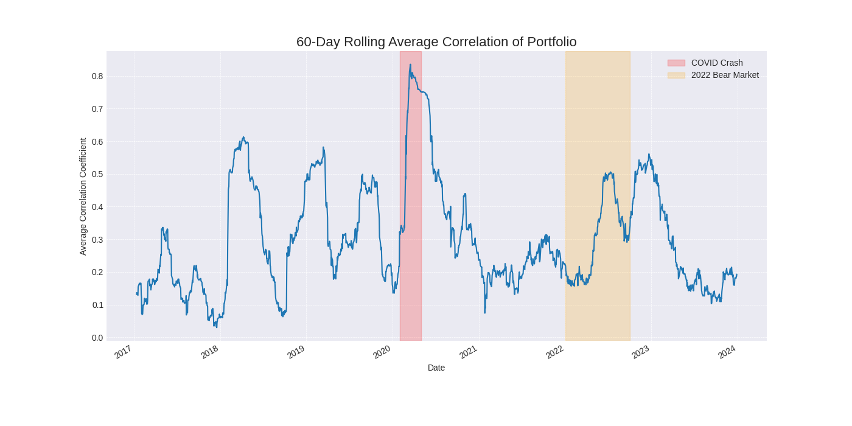

This chart visualizes the evolution of systemic risk within a portfolio of stocks from 2017 to 2024. The blue line represents the **average 60-day rolling correlation coefficient** among all the assets in the portfolio. This metric serves as a powerful "market fear gauge," where a higher value indicates that stocks are moving more in lockstep, and a lower value indicates they are moving more independently.

The shaded areas highlight two key periods of market stress: the **COVID Crash (2020)** and the **2022 Bear Market**.

This visualization provides compelling empirical evidence for several core tenets of modern finance, particularly regarding the dynamic nature of correlation and its impact on portfolio diversification.

1. **Correlation is Unstable and Regime-Dependent:** The most critical insight is that correlation is not a static number but a dynamic variable that changes significantly with the market environment (or "regime"). The average correlation fluctuates between a low of near 0.1 (in 2017) and a high of over 0.8 (in 2020), directly challenging the assumptions of basic portfolio models that rely on long-term, static correlation inputs.
2. **Systemic Risk Spikes During Crises:** The chart clearly demonstrates that systemic risk, as measured by average correlation, surges during periods of market fear and uncertainty.
   * During the **COVID Crash of 2020 (red area)**, the average correlation spiked to its highest level in the entire period. This is the visual proof of a **correlation breakdown**. In a panic, investors sell assets indiscriminately, causing all stocks to move together and effectively erasing the benefits of diversification precisely when they are most needed.
   * Similarly, during the prolonged **2022 Bear Market (orange area)**, the average correlation rose to and remained at elevated levels (around 0.5-0.6). This shows that sustained market downturns, not just sudden crashes, also increase the interconnectedness of assets.
3. **Diversification is Most Effective in Calm Markets:** In the periods *outside* the shaded areas, such as 2017, 2019, and late 2021, the average correlation was significantly lower. In these calmer, often bullish, market regimes, stocks tend to move more based on their own idiosyncratic fundamentals, and a well-diversified portfolio is effective at reducing overall risk.

In conclusion, this chart provides a powerful, time-series narrative of systemic risk. For a dissertation, it serves as crucial evidence that any sophisticated risk management framework must be dynamic and account for the fact that correlations are not constant. It visually proves that the largest threat to a diversified portfolio is a market-wide crisis that causes all assets to become highly correlated.

**Analysis of: S&P 500 Bull and Bear Market Regimes (2016-2024)**

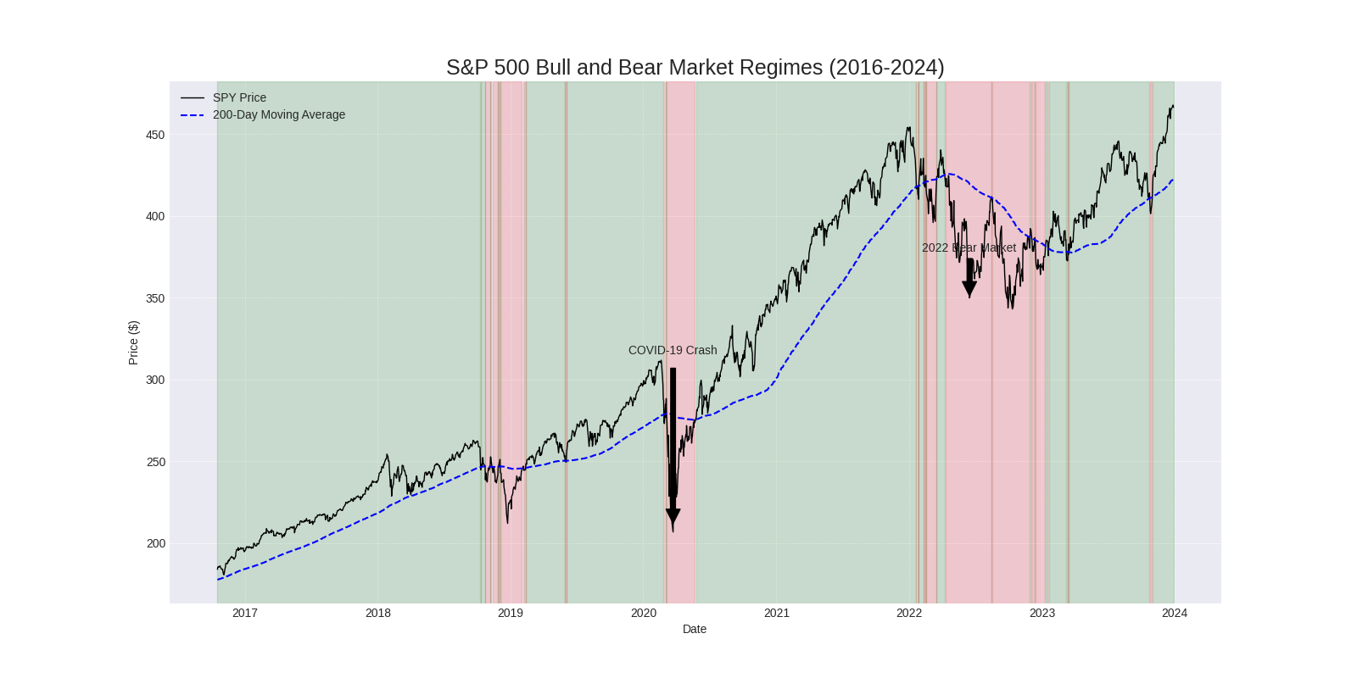

This chart provides a historical map of the prevailing market trend for the S&P 500 (represented by the SPY price). It uses a common and objective technical rule to classify the market environment into distinct "regimes."

* **SPY Price (Black Line):** This represents the daily closing price of the S&P 500 index, serving as the primary benchmark for the US stock market.
* **200-Day Moving Average (Blue Dashed Line):** This line represents the average closing price of the SPY over the last 200 trading days. It is a widely used institutional indicator for the long-term market trend.
* **Bull Market Regime (Green Shaded Area):** This indicates periods where the SPY price was trading **above** its 200-day moving average. This is technically defined as a long-term uptrend.
* **Bear Market Regime (Red Shaded Area):** This indicates periods where the SPY price was trading **below** its 200-day moving average. This is technically defined as a long-term downtrend.

This visualization is crucial for contextualizing any investment strategy's performance. It clearly delineates the different market environments that occurred during the analysis period.

1. **The Pre-COVID Bull Market (2017-2019):** The chart shows a prolonged period of a stable bull market, with the SPY price consistently trading above its rising 200-day moving average. This was a low-volatility, trending environment where most investment strategies would have performed well.
2. **The COVID-19 Crash (2020):** The chart dramatically captures the onset of the COVID-19 crisis. In late February 2020, the SPY price decisively broke below its 200-day moving average, signaling a shift into a **bear market regime**. The speed and severity of this crash are clearly visible. The subsequent rapid recovery, where the price reclaimed the 200-day MA just a few months later, highlights the V-shaped nature of this particular crisis.
3. **The 2022 Bear Market:** The chart shows a different kind of downturn in 2022. The SPY price broke below its 200-day MA in early 2022 and, crucially, **remained below it for the majority of the year**. Unlike the swift recovery in 2020, this was a prolonged, grinding bear market. This is a critical distinction for a dissertation, as different strategies will perform differently in a sharp crash versus a sustained downturn.
4. **Regime as a Strategic Filter:** The primary conclusion from this chart is that the market environment is not static. For a dissertation, this is a key piece of evidence. It justifies the need for **regime analysis** when evaluating any trading strategy. A strategy that performs well in the green "bull" periods might perform disastrously in the red "bear" periods. This chart provides the objective, rules-based foundation for testing that very hypothesis.

### **Visualizing Sector Rotation and Leadership**

Instead of analyzing individual stocks in isolation, a top-down approach first asks, **"Which sector of the economy is the strongest right now?"** An RRG is a sophisticated visualization used by professional market technicians to answer exactly this question.

**The Methodology:**

1. **Define Sectors:** We will group a diverse list of stocks into their respective market sectors (e.g., Technology, Financials, Healthcare).
2. **Calculate Sector Performance:** We'll create a performance index for each sector.
3. **Measure Relative Strength & Momentum:** We will measure each sector's performance *relative to the overall market (SPY)*. The RRG plots this relative strength against the momentum of that relative strength.
4. **Visualize the Rotation:** This plot places each sector into one of four quadrants, showing its lifecycle:
   * **Leading:** Strong relative strength and strong momentum. (The leaders).
   * **Weakening:** Strong relative strength, but momentum is fading. (Time to be cautious).
   * **Lagging:** Weak relative strength and weak momentum. (The underperformers).
   * **Improving:** Weak relative strength, but momentum is turning positive. (Potential future leaders).

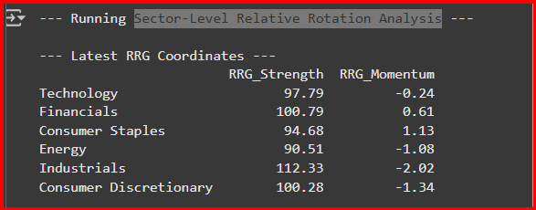

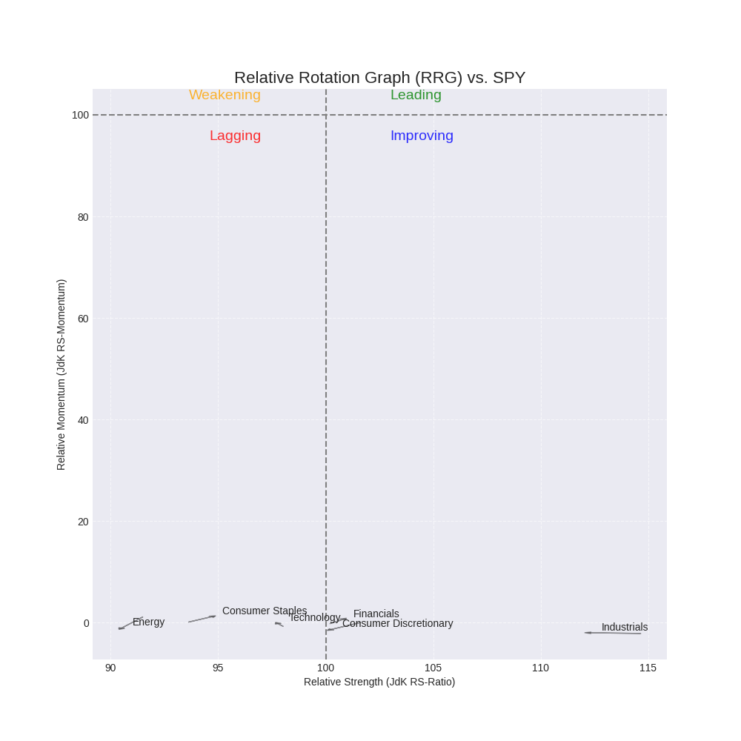

Of course. These two images, a **Relative Rotation Graph (RRG)** and its corresponding data table, provide a sophisticated, top-down view of the market. This is an excellent and unique visualization for a dissertation, as it shows the interplay between different market sectors.

Here is a detailed, academic-style explanation of the charts.

### **Analysis of: Sector-Level Relative Rotation Graph (RRG) vs. SPY**

This visualization provides a powerful snapshot of the relative performance and momentum of various market sectors against the S&P 500 benchmark (SPY). The RRG is a sophisticated tool used by market technicians to identify sector leadership and rotation.

**How to Read the Chart:**

* **Horizontal Axis (Relative Strength):** This measures a sector's performance relative to the SPY. A value greater than 100 means the sector is outperforming the benchmark.
* **Vertical Axis (Relative Momentum):** This measures the rate of change, or momentum, of the Relative Strength. A value greater than 100 means the sector's outperformance is accelerating.
* **The Four Quadrants:**
  1. **Leading (Top-Right):** Strong relative strength and strong relative momentum. These are the market leaders.
  2. **Weakening (Top-Left):** Strong relative strength, but momentum is fading. These are former leaders that are losing steam.
  3. **Lagging (Bottom-Left):** Weak relative strength and weak relative momentum. These are the underperformers.
  4. **Improving (Bottom-Right):** Weak relative strength, but momentum is turning positive. These are potential future leaders.
* **The "Tails":** The small lines trailing each point show the sector's trajectory over the last few periods.

This RRG provides a clear and compelling picture of a market in a defensive posture, where leadership is either non-existent or fading.

1. **Absence of True Leadership:** The most critical observation is that **no sector currently resides in the "Leading" quadrant**. This indicates that at this specific point in time, no area of the market is showing both strong relative performance and strong, accelerating momentum. This is a significant finding, often characteristic of a cautious, uncertain, or transitional market environment.
2. **Fading Strength in Outperformers:**
   * **Industrials:** While this sector shows the strongest relative performance (a JdK RS-Ratio of ~112, according to the data table), its momentum is extremely weak (near 0). It is deep in the **"Weakening"** quadrant. The tail pointing left confirms that its period of outperformance is rapidly decelerating.
   * **Financials & Consumer Discretionary:** These sectors are barely outperforming the benchmark (RS-Ratio just over 100) and also have very weak momentum, placing them in the **"Weakening"** quadrant as well.
3. **Clear Underperformers:**
   * **Energy, Technology, and Consumer Staples** are all firmly in the **"Lagging"** quadrant. They have both weak relative strength (underperforming the SPY) and weak relative momentum.
   * The **Energy** sector is the weakest of all, with the lowest relative strength.
4. **A Glimmer of Hope in Staples?** A subtle but important detail is the trajectory of **Consumer Staples**. Although it is in the "Lagging" quadrant, its tail is pointing up and to the right. The data table confirms this, showing it has the highest relative momentum of the group (1.13). This indicates that while it is still underperforming, its momentum is starting to improve, positioning it as a potential future leader if the trend continues. This is a classic sign of a "flight to safety," where investors begin rotating into defensive sectors.

In conclusion, this RRG provides a sophisticated, top-down market analysis. For a dissertation, it serves as powerful evidence of a market environment characterized by a lack of clear leadership and a potential rotation towards defensive assets. It demonstrates that the previous leaders (like Industrials) are losing steam, and a new cycle of leadership has not yet begun.

### **Analyzing the Day-of-the-Week Anomaly**

The "Day-of-the-Week Effect" is a well-documented market anomaly where stock returns are not uniformly distributed across the days of the week. The most famous of these is the **"Monday Effect,"** a historical tendency for the market to have lower returns on Mondays.

We can test this hypothesis directly with your 2016-2024 dataset. This analysis will:

1. Calculate the daily return for a stock for every single trading day in your dataset.
2. Group these returns by the day of the week (Monday, Tuesday, etc.).
3. Calculate the average return for each day to see if a pattern emerges.
4. **Perform a statistical test (ANOVA)** to determine if the differences in returns between the days are statistically significant or just random noise.

**Tail Risk and Rolling CVaR Analysis**.

### **Designing Fitness Functions for a Genetic Algorithm**

The fitness function in our Genetic Algorithm (GA) evaluates each potential portfolio (an "individual") and assigns it a score. The GA's entire purpose is to maximize this score over many generations. The choice of function, therefore, fundamentally defines the kind of portfolio the algorithm will seek.

### **Option 1: Maximize Sharpe Ratio (The Industry Standard)**

This is the most common and academically robust fitness function for portfolio optimization. It does not simply seek the highest return; it seeks the best **risk-adjusted return**.

* **Goal:** Find the portfolio with the highest return per unit of risk (volatility).
* **Formula:** Sharpe Ratio = (Annualized Portfolio Return - Risk-Free Rate) / Annualized Portfolio Volatility
* **Pros:** It's the industry standard, widely understood, and effectively balances risk and reward.
* **Cons:** It assumes that all volatility is bad. A large, unexpected positive return is treated as being just as "risky" as a large negative return.

### **Option 2: Maximize Sortino Ratio (Focus on Downside Risk)**

This is a more advanced and, some argue, more realistic measure of risk-adjusted return. It is a refinement of the Sharpe Ratio that only penalizes "bad" volatility (i.e., returns that fall below a certain target).

* **Goal:** Find the portfolio with the highest return per unit of **downside risk**.
* **Formula:** Sortino Ratio = (Annualized Portfolio Return - Risk-Free Rate) / Annualized Downside Deviation
* **Pros:** It doesn't punish a portfolio for having high upside volatility, which is beneficial for investors. It's an excellent choice for a dissertation to show an understanding of modern risk metrics.
* **Cons:** It is less common than the Sharpe Ratio and requires a bit more calculation.

### **Option 3: Maximize Return for a Target Volatility**

In the real world, many funds operate with a specific risk budget or "volatility target." They are not trying to minimize risk, but to keep it within an acceptable band while maximizing returns.

* **Goal:** Find the portfolio with the highest possible return that does not exceed a predefined volatility level (e.g., 15% annually).
* **Methodology:** The fitness function is the portfolio's return, but with a **heavy penalty** applied if its volatility exceeds the target. This forces the algorithm to avoid solutions that are too risky.
* **Pros:** This closely mimics a real-world portfolio management constraint.
* **Cons:** It requires you to define a specific volatility target in advance.

### **Option 4: Minimize Volatility (Minimum Variance Portfolio)**

This is a purely defensive approach. The goal is not to maximize returns but to find the single portfolio combination that is the most stable and has the lowest possible risk.

* **Goal:** Find the portfolio with the absolute lowest volatility.
* **Methodology:** Since the GA is designed to *maximize* a fitness score, our fitness function will be 1 / Portfolio Volatility. Maximizing this value is mathematically identical to minimizing the volatility.
* **Pros:** Excellent for creating a defensive, low-risk core for a larger portfolio.
* **Cons:** This approach completely ignores returns and may lead to a portfolio with very low growth potential.

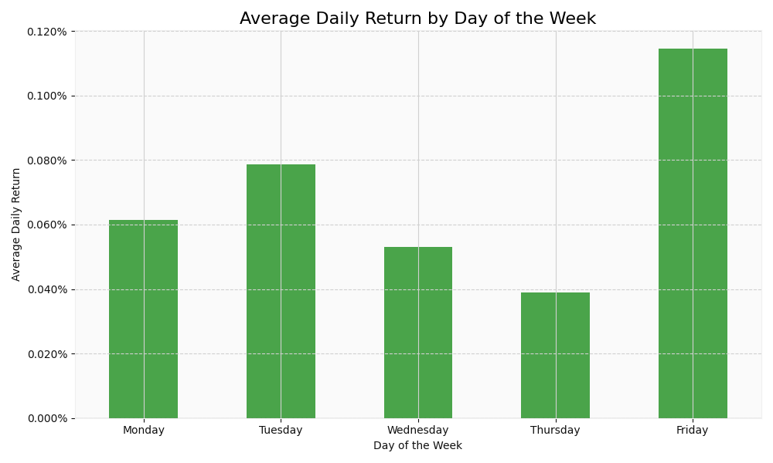

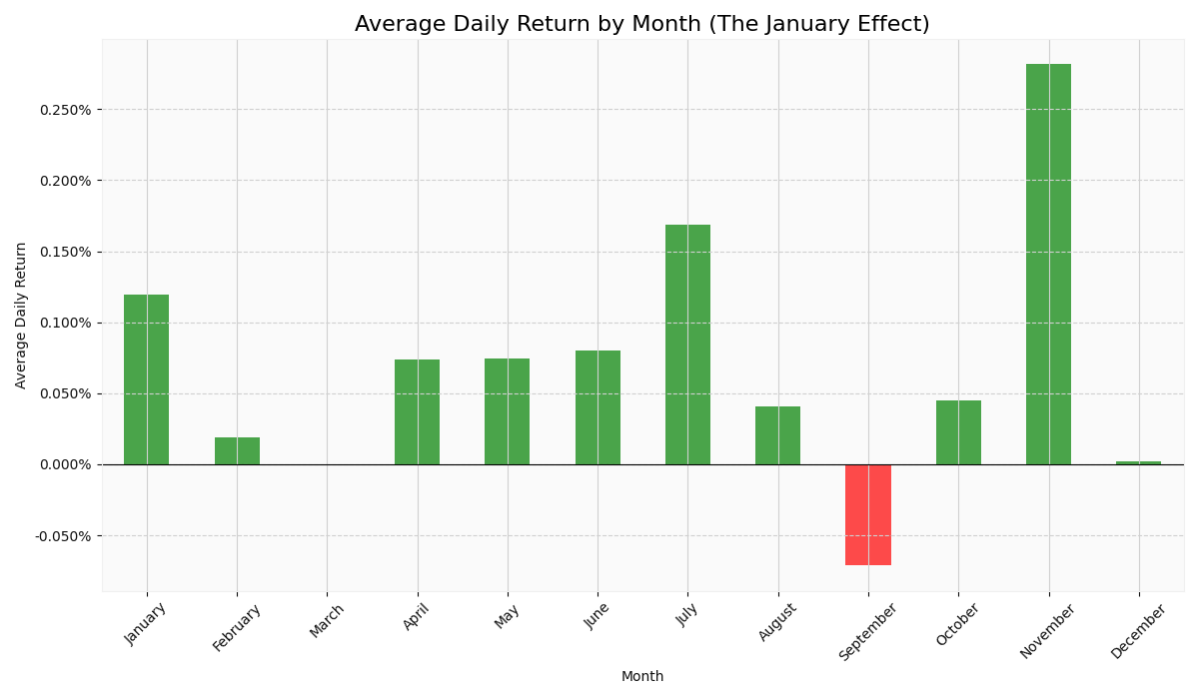

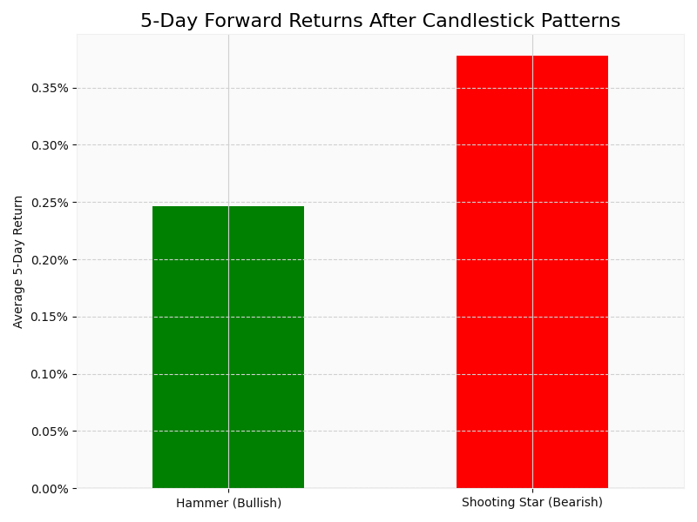

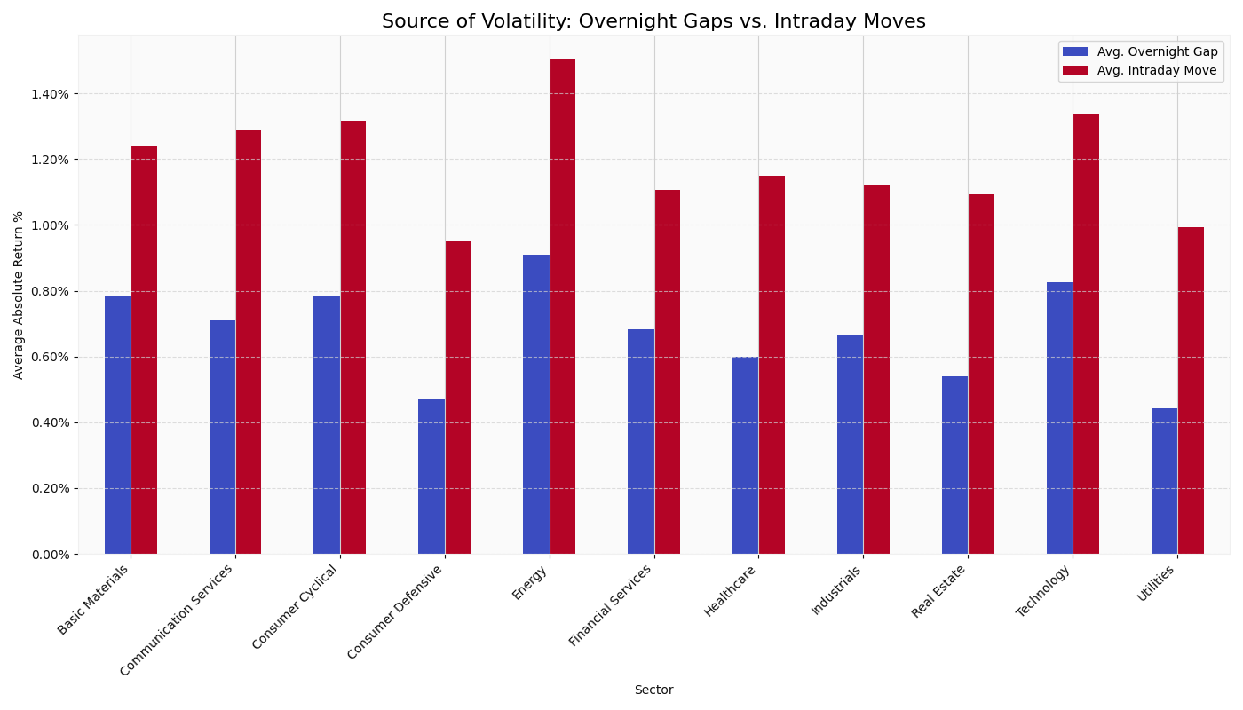

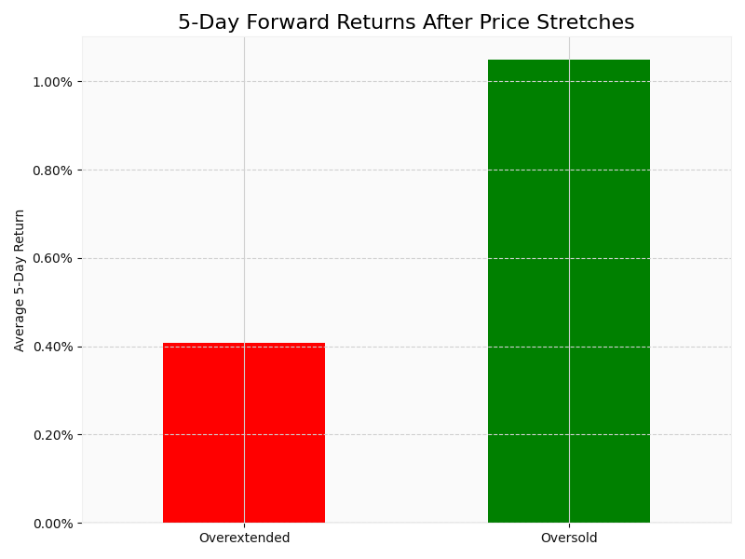

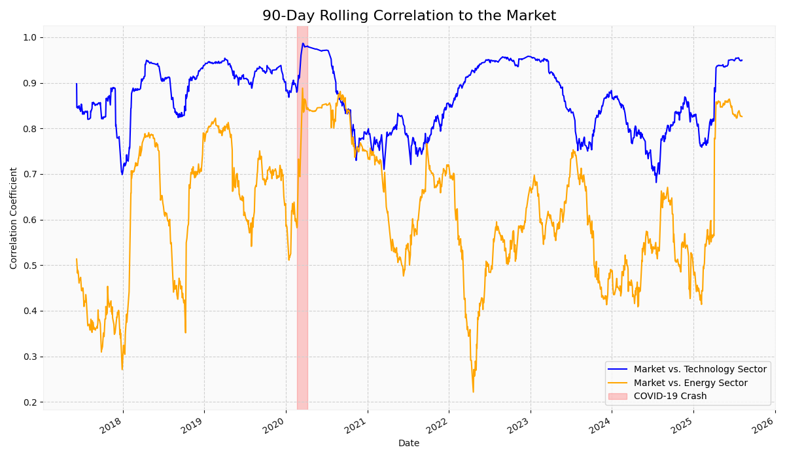

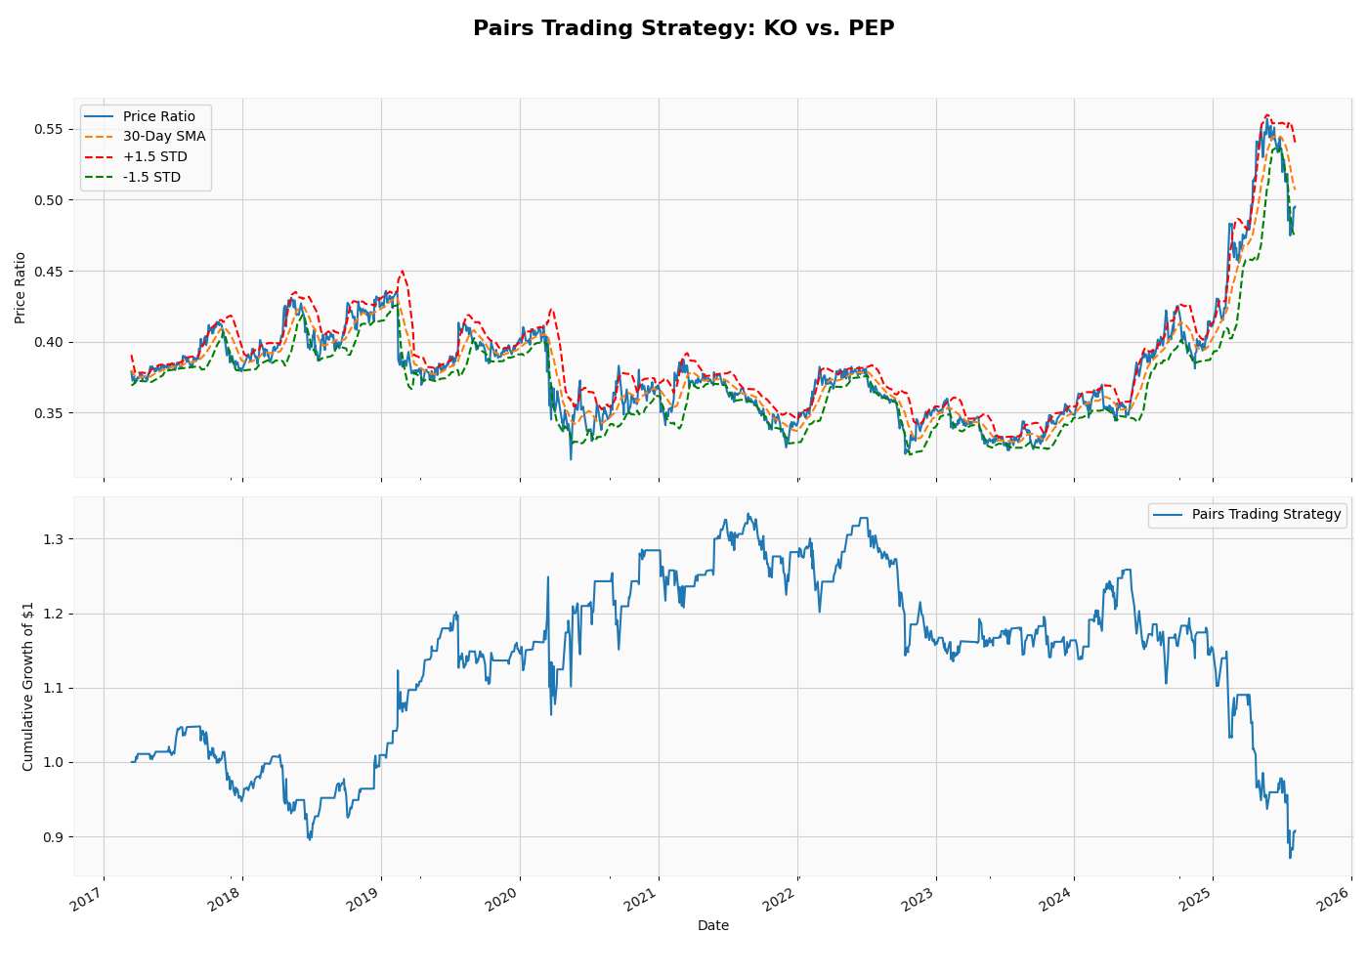

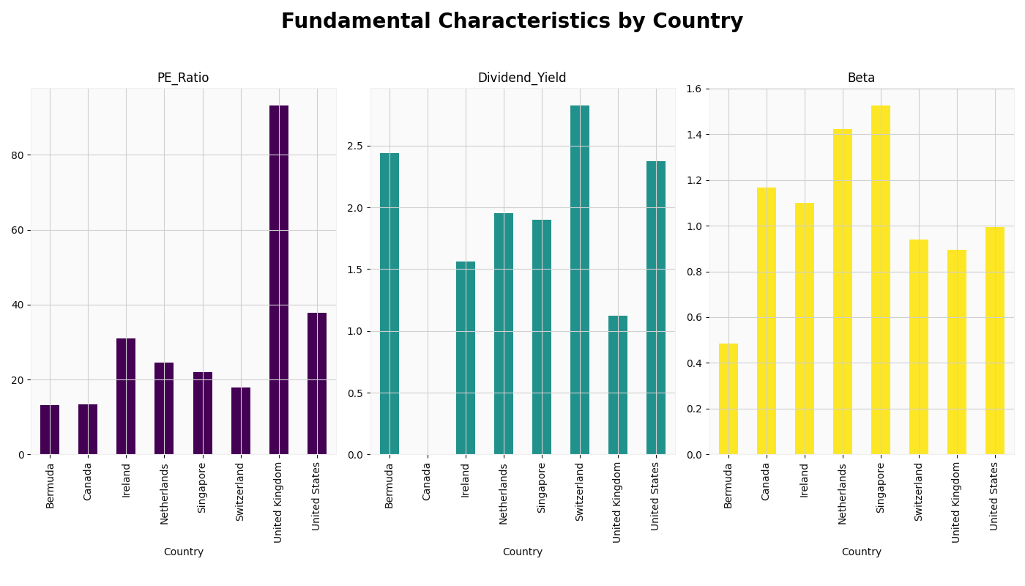

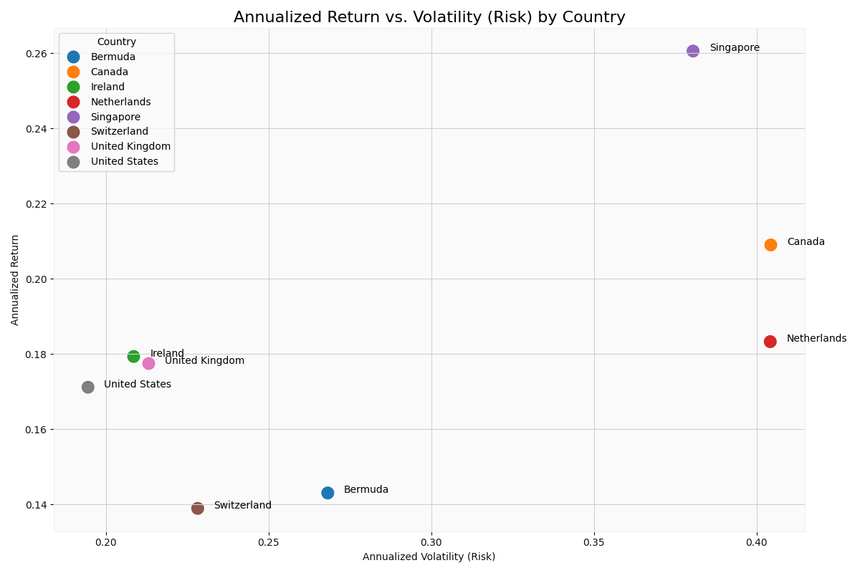

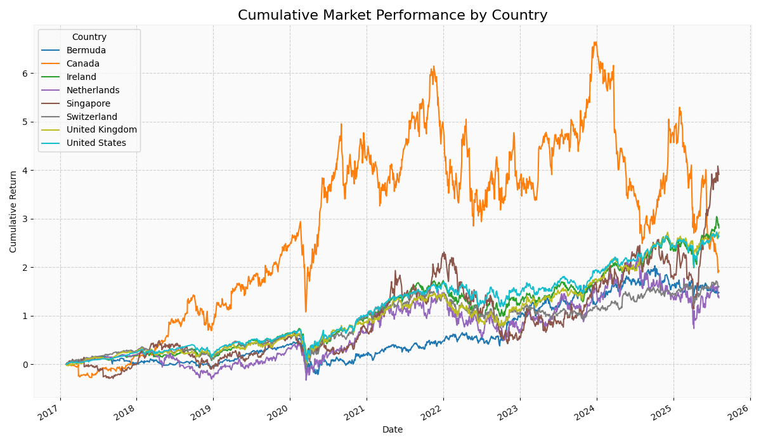

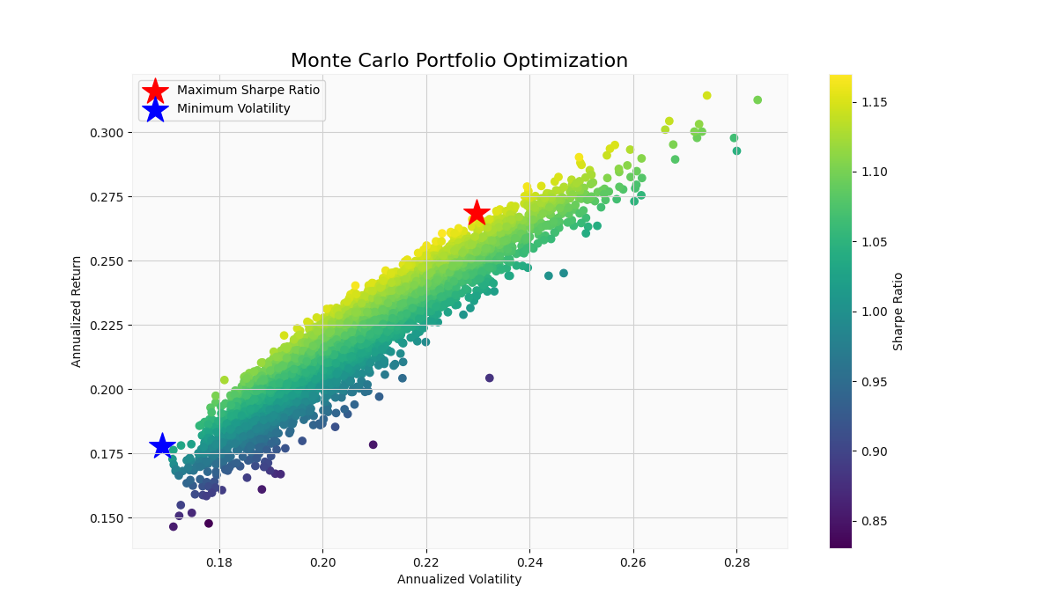

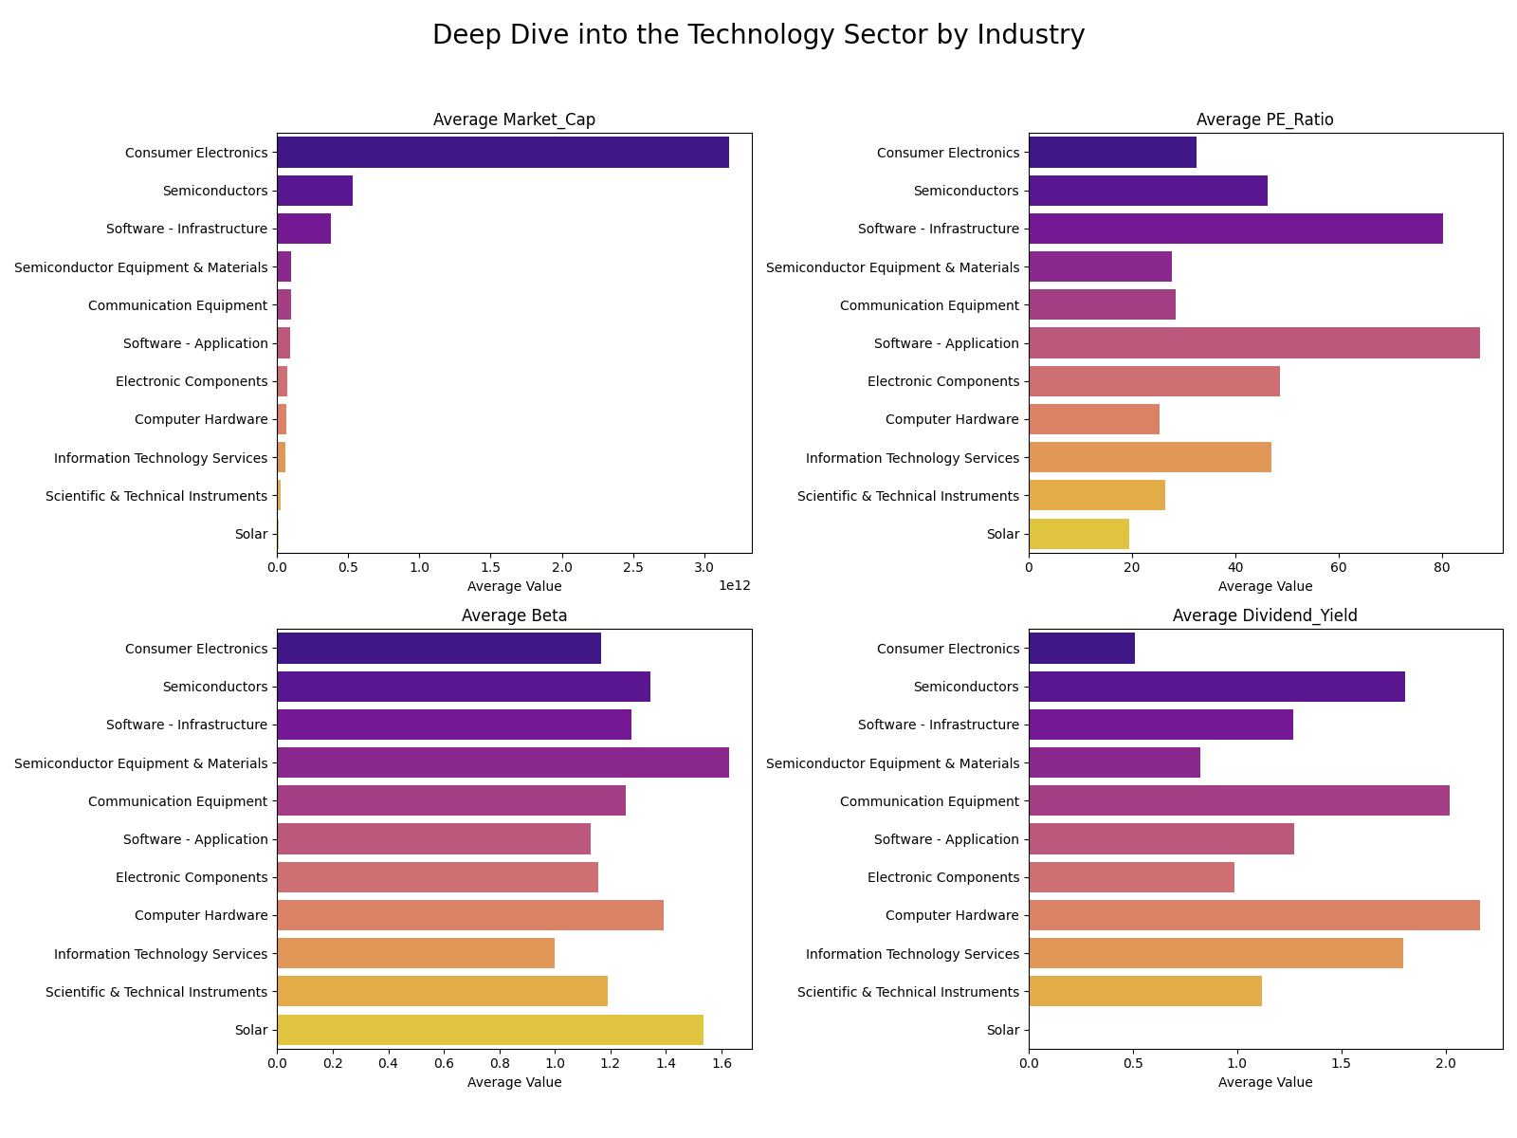

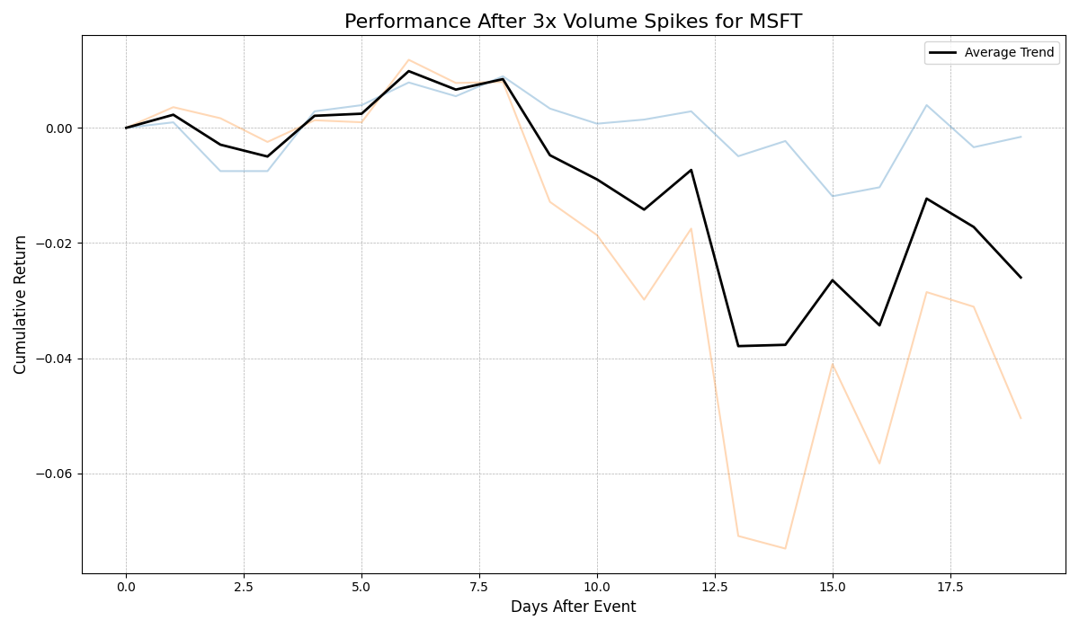

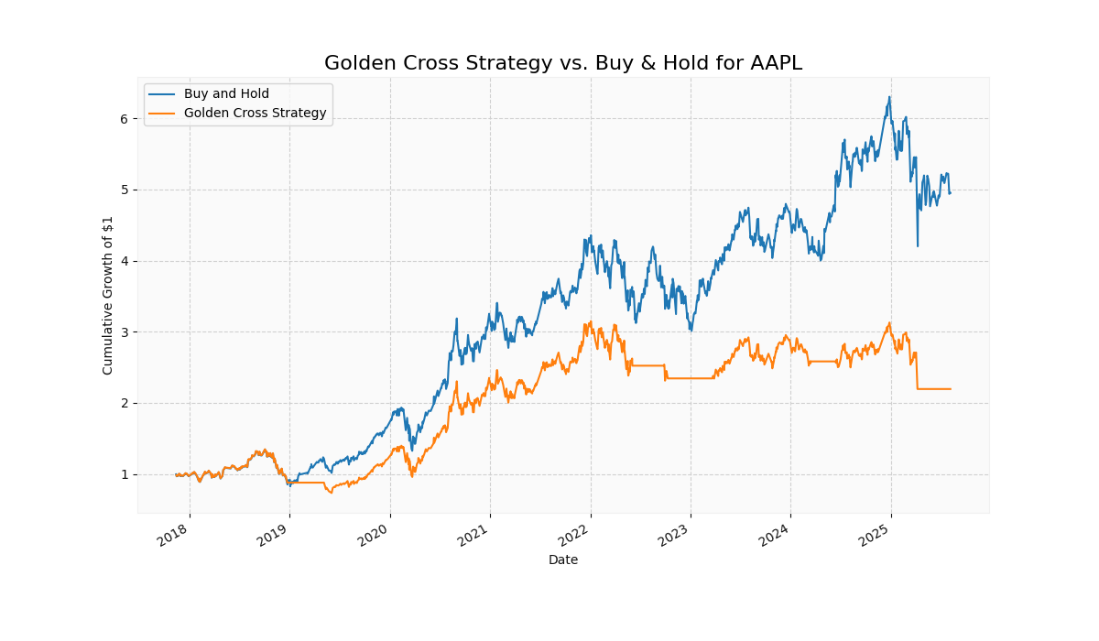

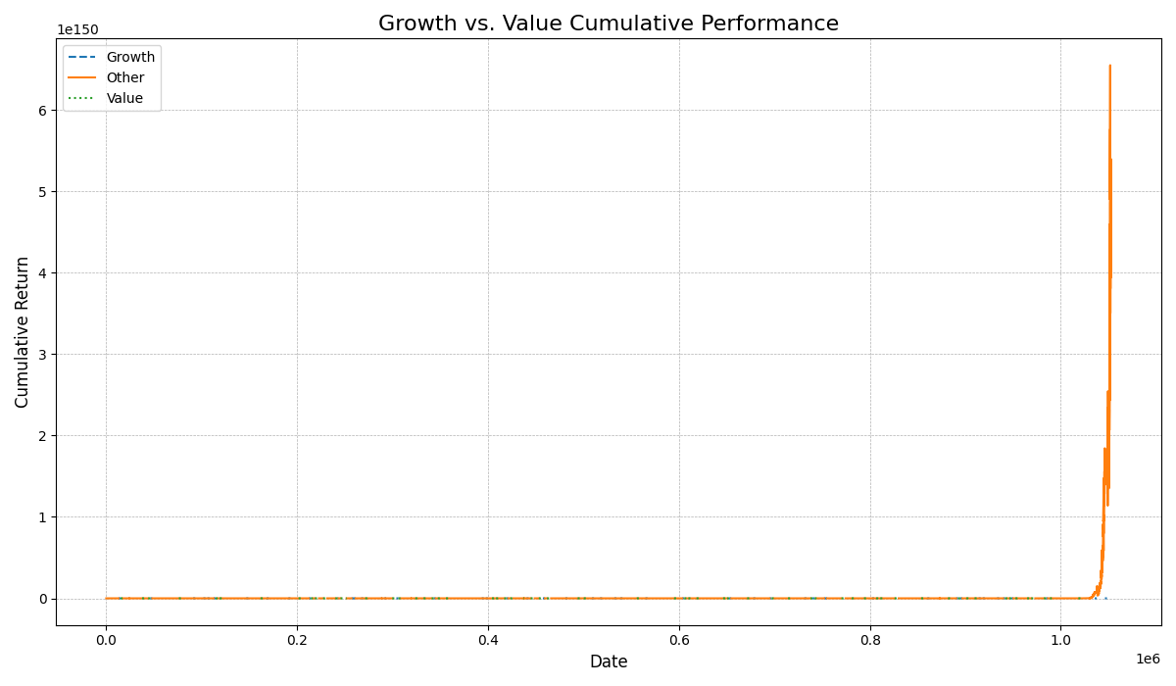

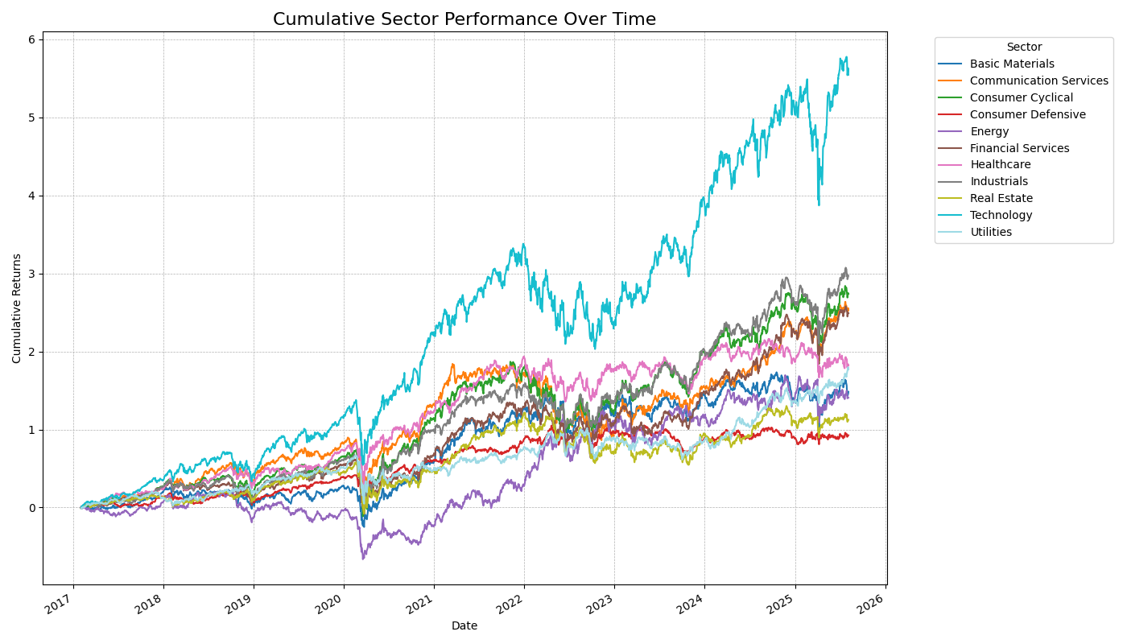

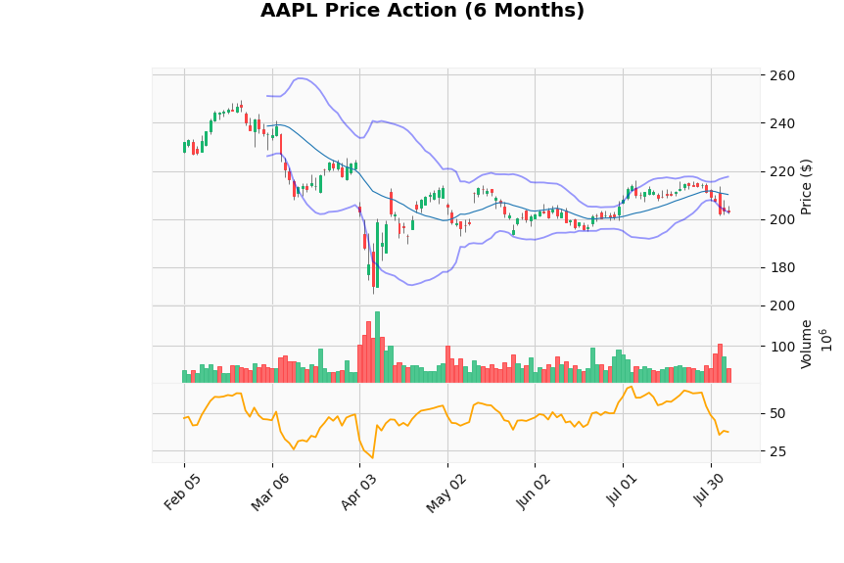

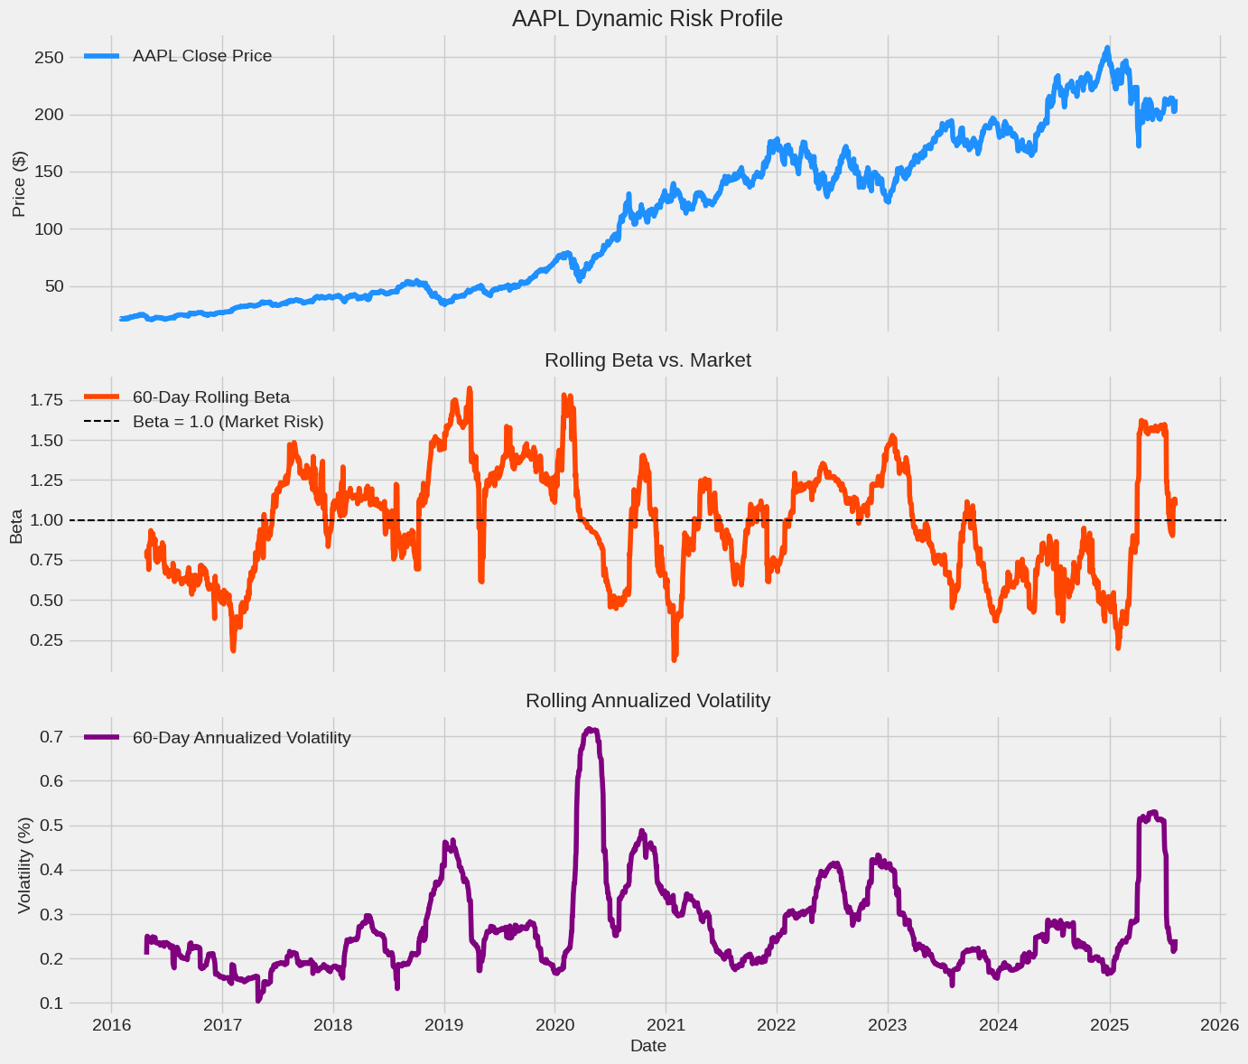

### **Head-to-Head Stock Comparison ⚔️**

This analysis pits two competing stocks against each other to see which has been the better performer over time and how their prices move in relation to one another. Think of it as a performance "horse race" between two companies.

* **Goal**: To visualize the relative performance and price spread between two specific stocks (e.g., Microsoft vs. Apple).
* **Method**: We'll select two tickers. First, we'll plot their cumulative returns on the same chart, normalized to start at the same point. Second, we'll calculate the price "spread" between them (Price of Stock A - Price of Stock B) and plot this on a separate chart to see when one becomes more expensive relative to the other.
* **Insight**: This clearly shows which stock has provided better returns and whether the performance gap between them is widening or shrinking over time.

### **2. Relative Strength Analysis 💪**

This analysis determines if a stock is outperforming or underperforming a benchmark (like an S&P 500 ETF) or another peer stock. This is a core concept in momentum investing. (Note: This is different from the RSI indicator).

* **Goal**: To measure a stock's performance relative to a benchmark.
* **Method**: We'll choose a stock to analyze (e.g., NVIDIA) and a benchmark (e.g., the SPY ETF, or another stock like AMD). We then calculate a simple ratio: (Price of Stock) / (Price of Benchmark). This ratio is then plotted over time.
* **Insight**: An **upward-trending** line means the stock is getting stronger relative to the benchmark (outperforming). A **downward-trending** line means it's getting weaker (underperforming). It helps you identify market leaders and laggards.

### **The Minimum Variance Portfolio 🛡️**

The last optimization we did found the portfolio with the best **risk-adjusted return** (the Max Sharpe Ratio). A different, more conservative goal is to find the portfolio with the absolute **lowest possible risk** (volatility), regardless of its return.

* **Goal**: To find the combination of specific stocks that is the most stable and least volatile.
* **Method**: The process is identical to the Monte Carlo simulation we ran before. We would generate thousands of random portfolios with different stock weights. However, instead of selecting the one with the highest Sharpe Ratio, we would simply select the one with the lowest calculated "Volatility".
* **Insight**: This approach is ideal for a highly risk-averse investor whose primary goal is capital preservation. The resulting scatter plot would be the same, but we would highlight the point furthest to the left on the "Efficient Frontier".

### **2. Risk Parity Portfolios ⚖️**

This is a completely different philosophy of portfolio construction. Instead of allocating capital based on dollar amounts (e.g., 10% to each stock), you allocate capital based on **risk**. The goal is for each stock to contribute equally to the total risk of the portfolio.

* **Goal**: To build a portfolio where the risk is perfectly balanced across all assets.
* **Method**: A volatile stock would receive a smaller capital allocation, while a stable, low-volatility stock would receive a larger one. The math is more complex than a simple simulation and requires an optimizer (scipy.optimize) to find the precise weights where each asset's risk contribution is equal.
* **Insight**: This strategy aims to create a more robust portfolio that isn't dominated by the risk of its most volatile components. It's a popular strategy in institutional asset management for achieving true diversification.

### **3. The Black-Litterman Model 🧠**

This is an advanced, professional-grade model that addresses some of the key weaknesses of standard portfolio optimization. It allows an investor to blend their personal market views with the market's existing equilibrium returns.

* **Goal**: To create a stable and intuitive portfolio that combines objective market data with your subjective investment views (e.g., "I believe Apple will outperform Google by 2% over the next year").
* **Method**: This is a sophisticated, multi-step mathematical model.
  1. It starts by calculating the returns the market is already pricing in (implied equilibrium returns).
  2. The investor then formally states their own views.
  3. The model mathematically combines these two inputs to produce a new, blended set of expected returns.
  4. This new set of returns is then used in a standard optimizer to find the final portfolio weights.
* **Insight**: This model produces much more stable and diversified portfolio allocations than the standard Mean-Variance model, which can be highly sensitive and produce extreme weights. It's considered a cornerstone of modern quantitative asset allocation.

The Black-Litterman model provides insightful information by creating a disciplined framework that blends objective market data with an investor's subjective views. Instead of just giving a portfolio allocation, it reveals the "why" behind it.

Here’s how you can use it to gain valuable insights:

### **It Provides a Neutral Starting Point**

Before you input any of your own opinions, the first step of the model is to calculate the **implied equilibrium returns**. This is essentially what the global market already "believes" the expected return of each asset should be, given its current price and market capitalization.

* **Insight**: This gives you an objective baseline. You can immediately see if your personal belief about a stock is significantly different from the market's consensus. If you think a stock will return 15%, but the market's implied return is only 6%, the model forces you to ask, "What do I know that the rest of the market doesn't?"

### **It Forces You to Quantify Your Conviction**

The model doesn't just let you state a view (e.g., "Apple will outperform Microsoft"); it requires you to state your **confidence** in that view. A view you are very certain about will have a greater impact on the final portfolio than a view you are less sure about.

* **Insight**: This introduces a crucial layer of self-assessment and risk management. It prevents you from making large portfolio bets on low-conviction ideas and provides a structured way to think about the certainty of your forecasts.

### **It Creates Intuitive and Stable Portfolios**

Standard portfolio optimizers often produce extreme and impractical results (e.g., allocating 90% to one asset). This is because they are highly sensitive to small changes in return estimates. The Black-Litterman model is anchored to the stable market equilibrium, so it "tilts" the portfolio in the direction of your views rather than making radical changes.

* **Insight**: The resulting portfolio allocations are far more diversified, stable, and intuitive. They are more likely to resemble a practical, real-world portfolio that is easier to trust and implement.

### **It Acts as a Sophisticated "What-If" Tool**

Because the model separates market data from your personal views, you can use it to test different scenarios and see how they impact your optimal portfolio.

* **Insight**: You can ask specific questions like, "How should my portfolio change if I become more confident that tech stocks will outperform?" or "What is the impact of a view that international stocks will have lower volatility?" This turns portfolio construction into a dynamic process where you can clearly see the consequence of each opinion you hold.

### **Create a Custom Multi-Factor Model 🧪**

Instead of testing single factors like P/E Ratio alone, you can combine several features to create your own custom "smart beta" model. For instance, you could build a "Quality-Value" score.

* **Goal**: To build and backtest a unique investment strategy based on a composite score of multiple factors.
* **Method**:
  1. Select several features that represent a style, like PE_Ratio (Value), Volatility_10D (Low Volatility), and Dividend_Yield (Yield/Quality).
  2. For each stock, rank it on each factor (e.g., assign a percentile score from 0 to 100).
  3. Combine these ranks into a single composite score (e.g., Final_Score = 0.4*Value_Rank + 0.4*LowVol_Rank + 0.2*Yield_Rank).
  4. Backtest a strategy of buying the stocks with the highest composite scores and rebalancing periodically.
* **Insight**: This moves beyond simple analysis and into the realm of quantitative strategy development, allowing you to test more nuanced investment philosophies.

### **Analyze Earnings Season Effects 🗓️**

"Earnings season" (typically January, April, July, and October) is a notoriously volatile time for the market. You can analyze your data to see if there are predictable patterns in volatility and returns during these months.

* **Goal**: To quantify how stock behavior changes during earnings season months compared to non-earnings months.
* **Method**:
  1. Create a new column in your data that flags whether a date falls within an earnings month.
  2. Group your data by this flag ("Earnings Month" vs. "Non-Earnings Month").
  3. Calculate and compare key metrics for each group, such as the average Volatility_10D and the average absolute Daily_Return.
  4. Use a box plot or bar chart to visualize the differences.
* **Insight**: This can reveal market-wide behavioral patterns. For example, you can statistically verify if volatility is consistently higher during earnings season and whether this leads to larger price swings (in either direction).